End of Season Presentation Evening

Almost 250 players, coaches, managers and parents assembled in the “Re-load” cafeteria at Northampton School for Girls for the End of Season Presentation Evening of the Northants Basketball Club. After a hot buffet, coaches made presentations to one player from their team in acknowledgement of their achievements. They were also able to tell the audience about the highlights of their team’s season.
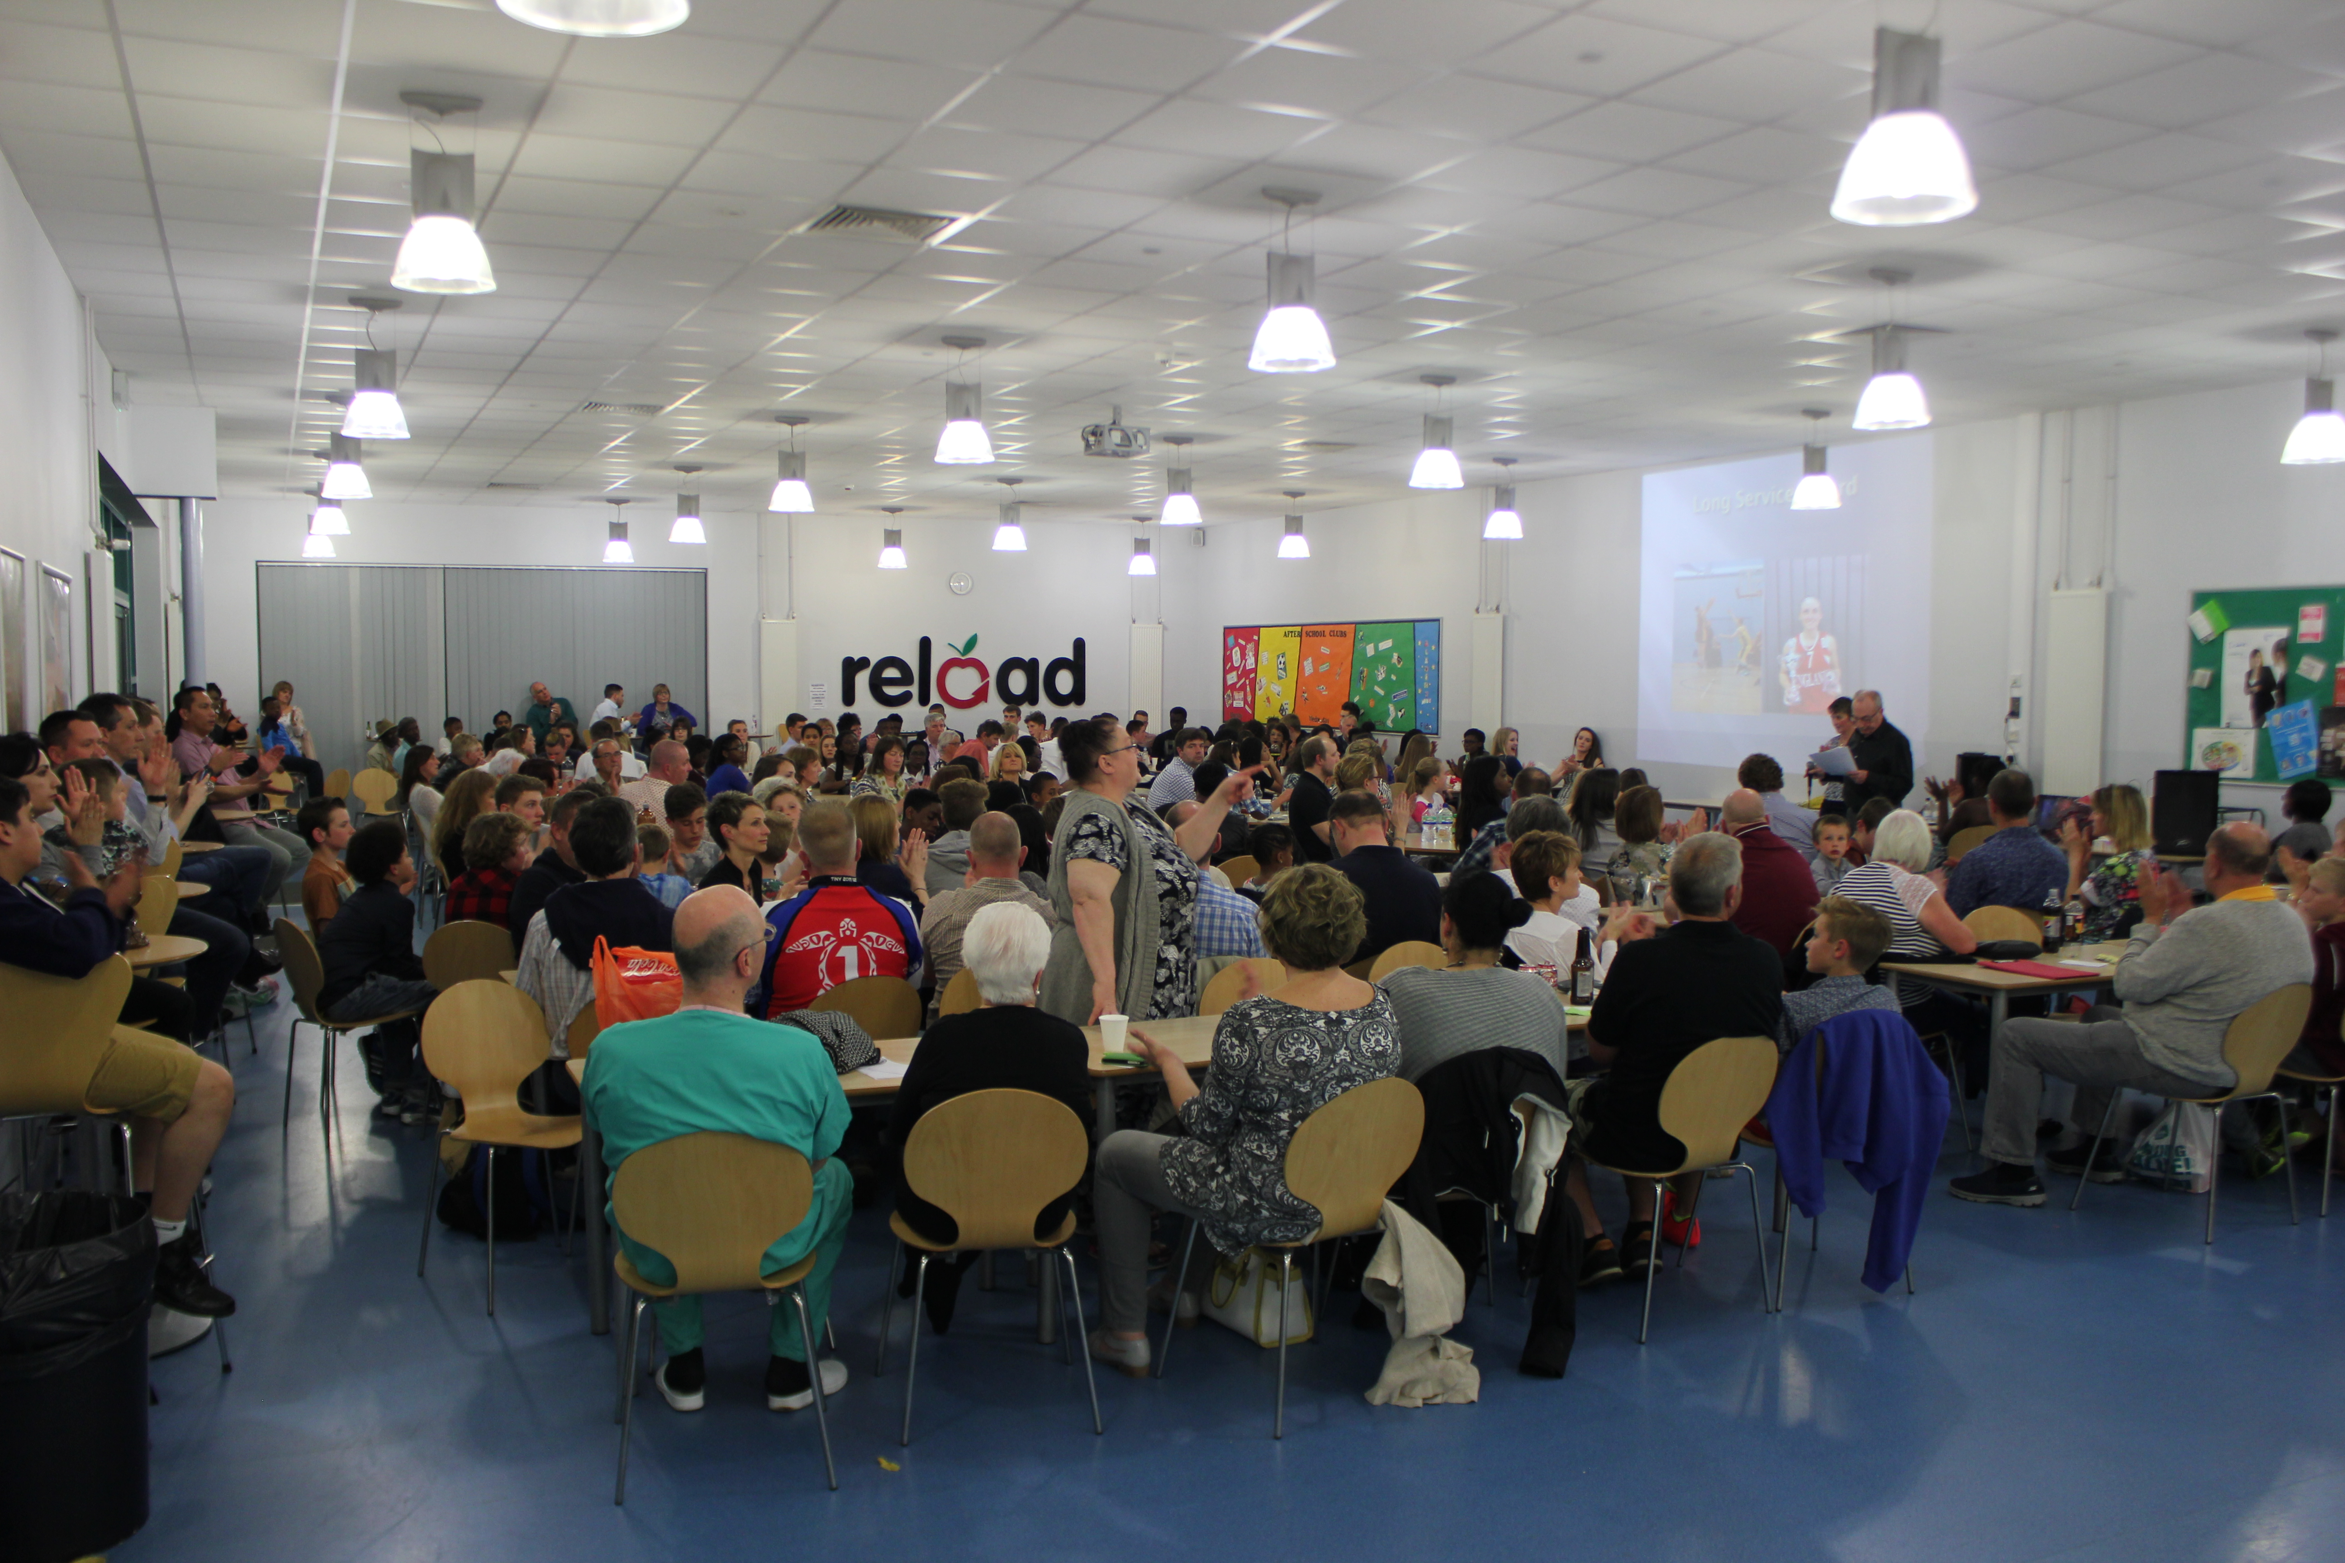

The award winners were:

U13 Boys Most Valuable Player - Ben Nailer

U14 Girls Most Valuable Player - Holly Winterburn

U14 Boys Most Valuable Player - Chris Amankonah

U15 Boys Most Improved Player - Ed Taylan

U16 Girls Most Valuable Player - Ruchae Walton

U16 Boys Most Valuable Player - David Nieva

U18 Girls Team Player - Harri Owens

U18 Boys Most Valuable Player - Ollie Thomas

Senior Women Most Valuable Player - Stephanie Ogden

Penny Westwood Fair Play Award
This was awarded to Under 16, Under 18 and Senior Women’s team player Caitlin Stewart who also table officiates and coaches in the Club

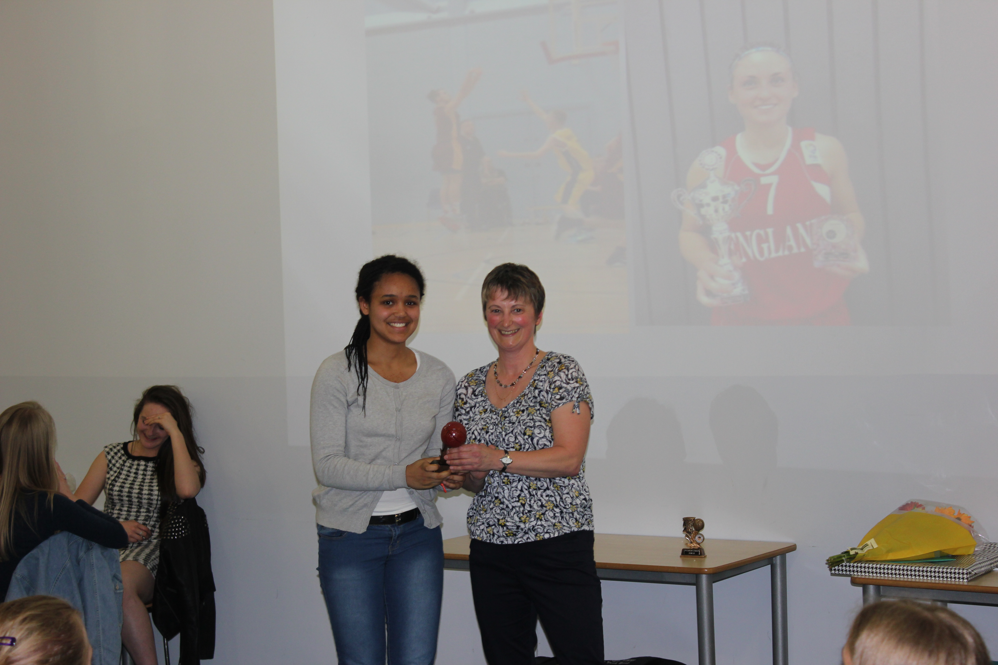

President's Award
This was awarded to Jacob Round for his massive contributions in helping the Under 15 and 16 teams reach the Play Offs.

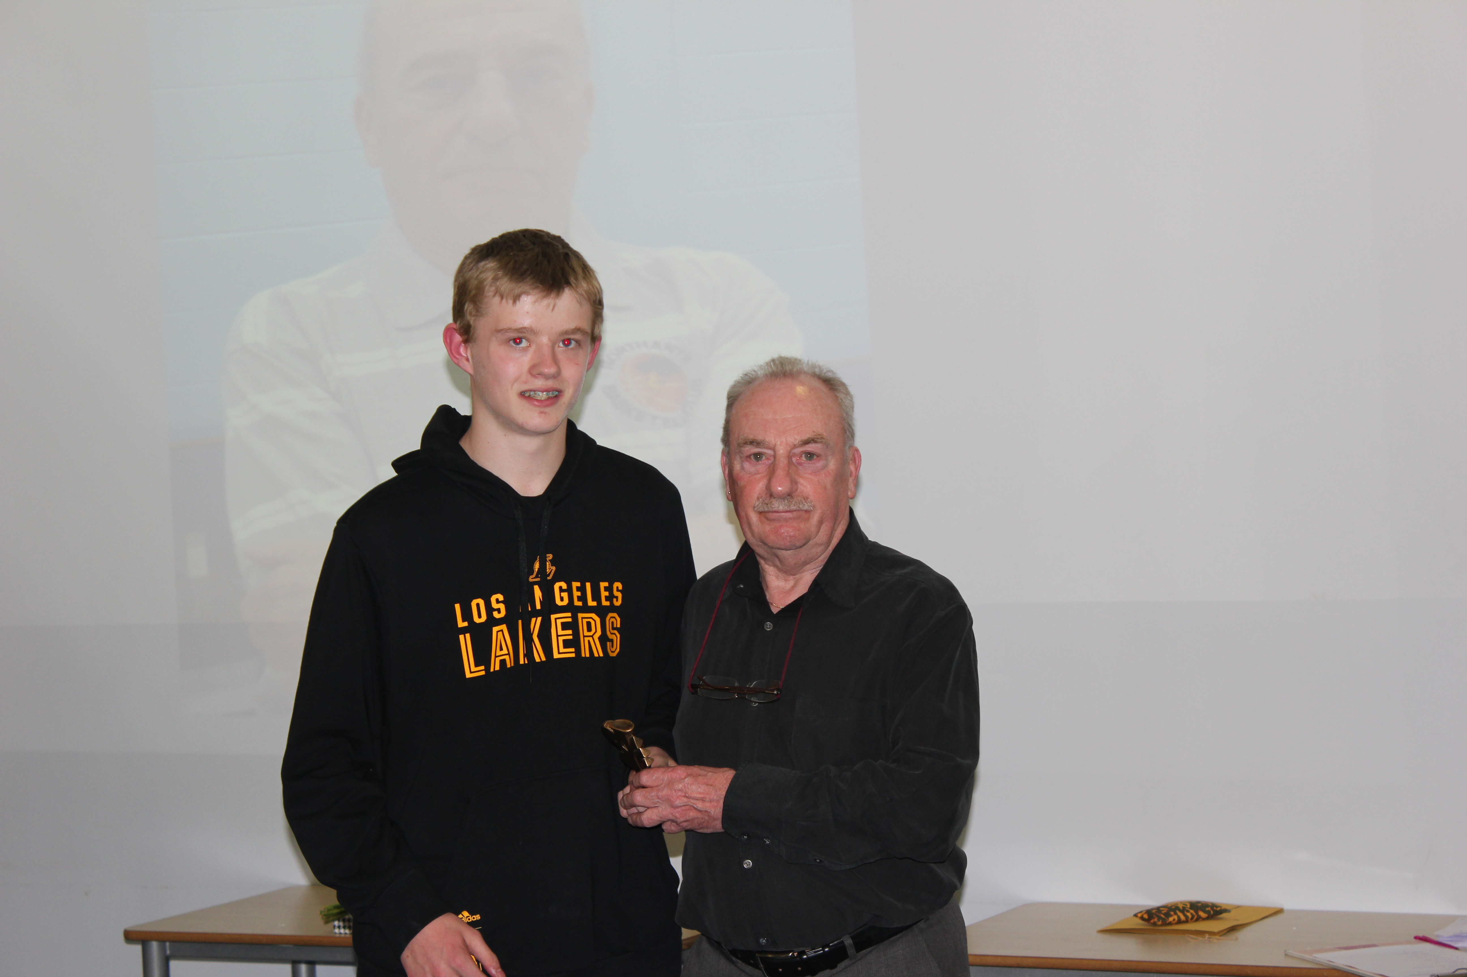

Long Service Awards
These were presented to players who have played in all the age group teams from Under 13 to Under 18 but are now leaving the programme. The recipients were, Riona Blessyn, Tara Hings, Luke Joines, Steph Ogden, George Paul and Josh Round.



