NORTHANTS BASKETBALL CLUB

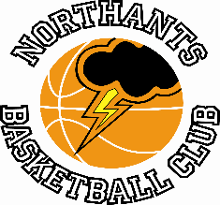

PRESS RELEASE

A busy weekend for teams from the Northants Basketball Club with no less than seven games with the highlights being wins for the Under 15 Boys over Leicester “Riders” and the Under 12 Mixed team over City of Birmingham “Rockets”

Tough weekend for the Under 16 Boys

Under 16 Boys Midlands Conference
Northants “Thunder” 32 – 69 Leicester “Riders”

The Northants Under 16 Boys opened 2023 with a game against Leicester “Riders” and came out very much second best. After a competitive first quarter which the visitors edged 12-10 the “Thunder” scoring just dried up and they could manage only a paltry 22 points over the next thirty minutes of play.

In the disappointing loss no “Thunder” player could score in double figures Danielus Jokulis and Paul Judd both contributing eight points apiece.

Northants “Thunder” 60 – 61 Northamptonshire “Titans”

Less than 24 hours after their disappointing performance against Leicester “Riders” the “Thunder” Under 16 Boys were back on court to take on local rivals Northamptonshire “Titans”. When the two teams had met in the first game of the season “Thunder” had clinched a two point win so another close contest was expected and so it proved.

Both teams found scoring difficult at the start of the game and fourteen shots were made and missed before Jake Muxlow converted a lay up a 6-2 surge at the end of the quarter gave “Titans” the initiative.

Baskets remained at the premium in the second quarter which “Thunder” took 11-9 and the two teams went into the lockers rooms at half time all tied at 21 apiece.

The third quarter opened with scores for Muxlow and Henry Brandrick and it seemed as if “Thunder” had seized the initiative but “Titans” then went on a 14-zero charge to take the lead at 35-25. “Thunder” were able to re-group and battled hard to close the gap but were still trailing 34-41 at the end of the quarter.

“Titans” were able to keep their noses in front through the final quarter thanks in no small part to the contributions of Ntumba who scored ten points in the final stanza. With two minutes of the game remaining “Titans” held a ten point advantage and the game looked done and dusted but scores from the Logans Ormshaw and Tanner and Danielas Jokulis got the score back to 55-58. As the game entered the final minute the large crowd was to witness the decisive play of the game. Ntumba was fouled, he missed both of the resulting free throws, but “Titans” Goodliffe swooped for an offensive rebound and a put back score plus a bonus free throw which he converted.

Leading 61-55 “Titans” seemed to have the game wrapped up but they fouled Angus Slater and he converted two free throws to close the gap before a crazy turn-over gave possession back to “Thunder”. Ormshaw drained a three-pointer but it was too little too late as “Titans” held on for the revenge single point win.

In the heart-breaking one-point loss Ormshaw led the “Thunder” scoring with 15 points while Ntumba contributed 20 points for “Titans”. The “Thunder” players may well reflect an alarming total of 19 free throws they missed

Easy win for Under 16 Girls

Under 16 Girls East Conference

Northants “Lightning” 88 – 19 Braintree “Blue Devils”

The “Lightning” Under 16 Girls got back to winning way with a comfortable victory over bottom of the table Braintree “Blue Devils”.

The game was as good as over by the end of the first quarter by which time “Lightning” had raced out to 23-4 lead. This was extended to 49-8 by half time with the Braintree girls struggling to cope with the speed and power of “Lightning’s” play.

There was a similar pattern in the second half but to their credit “Blue Devils” never gave up and their nine points in the fourth quarter was their best haul of the game.

In the big win eight “Lightning” players contributed to the 88-point total led by Lucie Caulfield and Jennifer Oamen with 24 and 22 points respectively while Karly Osgood contributed 14 points.

Things will be a lot tougher this coming weekend when the team make the long trip to Norfolk to take on “Inceni” a team they narrowly defeated earlier in the season.

Under 15 Boys hold on for a BIG win

YBL Under 15 Boys Primis
Northants “Thunder” 61 – 56 Leicester “Riders”

Without a game for several weeks the “Thunder” Under 15 Boys picked up a big ‘scalp’ in the form of high-flying Leicester “Riders”. The win came on the back of and excellent all-round team performance with major points contributions coming from Fran Guel, Jasper Roache and George Clipson but not without a few nervy moments at the end of the game. With less than two minutes of the game remaining “Thunder” held a comfortable eight point lead at 57-48 but they were unable to close out the game efficiently allowing “Riders” to go on an 8-2 run to close the gap to just three points but scores from James Kennett-Maughan saw “Thunder” home.

Earlier “Thunder” had edged the first three quarters of the game thanks to some excellent defence limiting their opponents to just 35 points.

This weekend the boys entertain Birmingham “Bears” a team they lost to by just three points earlier in the season.

Under 12 Mixed team see off “Rockets”

NBL Region 1 Conference
Northants “Storm” 52 -50 City of Birmingham “Rockets”

Wins against teams from the City of Birmingham club are few and far between so this victory was especially pleasing particularly because it was achieved without the services of leading scorer Dominykas Jokulis for most of the game and their leading rebounder Amelia Wesley-Maryan for the closing stages.

The two teams went into Sunday’s game with similar records so a close contest was to be expected and so it proved “Storm” surviving a nervous final two minutes during which time they failed to score.

“Rockets” edged the first quarter 13-12 but “Storm” responded well winning the second quarter 16-13 to take a narrow 28-26 half time lead. “Rockets” made a great start to the third quarter outscoring “Storm” 8-2 to take a 34-30 lead but some determined defence by “Storm” limited their opponents to just a further four points and the two teams went into the final quarter all level at 38 points each.

Needing a good start to the final quarter “Storm” were able to seize the initiative with 10-4 charge with Neitas Kurila scoring with two long range jump shots. “Storm” were helped considerably by “Rockets” inability to convert from the free throw line and “Storm” were able to hold on for the two-point win despite conceding two late baskets.

In the impressive win Kurila top scored for “Storm” with 12 points well supported by Samuel Dominici with 10 points but Coach John Collins was delighted that all eleven of his players had contributed to the 52 point total and even more pleased with the defensive efforts of Kyjah Adams and Max Abraham.

Gutsy Under 14 Girls second best in Leicester

Under 14 Girls North 2 Conference
Leicester “Riders” 70 – 54 Northants “Lightning”

After a number of weeks without a game the “Lightning” Under 14 Girls made the short trip to Leicester to take on a “Riders” team that had lost just one game all the season, and a spirited performance saw “Lightning” keeping pace with their opponents despite losing all four quarters.

Both teams found scoring difficult in the first ten minutes of play which “Riders” edged 15-13. That lead was extended to 35-27 by half time “Riders” benefitting from a height advantage which allowed them to score from put backs.

“Lightning” were able to keep in contact with their opponents for most of the third quarter relying on the scoring Jennifer Oamen and Amelia Wesley- Maryan but their ace shooter Campbell Spatcher was unable to find her range and a late surge saw “Riders” take the quarter 21-15 and establish what appeared to be and unassailable 56 to 42 lead.

The Northants girls mounted a massive effort in the final quarter but “Riders” held on for the win but their performance in this game must give the team every encouragement for a positive result against the Sheffield “Hatters” second string this coming weekend.

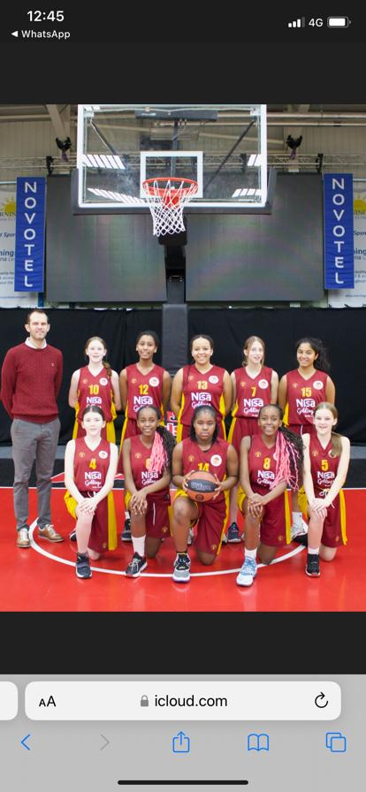

The “Lightning” Under 14 Girls team before their game against Leicester “Riders”

Under 11 Girls sparkle against Milton Keynes

Under 11 Girls friendly game
Northants “Lightning” 53 -32 Milton Keynes Basketball

Led by an excellent performance from Urte Maldutyte the “Lightning” Under 11 Girls recorded a comfortable win over a game Milton Keynes team.

The Northants girls have been working hard in their practices, all the players have improved and Coach Karen Goodrich was extremely pleased with the way they had played as a team.

THIS WEEKEND’S ACTIVITIES

Saturday 14th January
9-15am to 10-15am Budding “Ballers” session
10-15am to 11-30am Junior “Ballers” session

12.00 noon Under 18 Boys versus Oxford “Hoops”
2-15pm Under 14 Girls versus Sheffield “Hatters II”
4-30pm Under 15 Boys versus Birmingham “Bears”

Under 16 Boys travel to Leicester Dynamite”

Sunday 15th January
11-00am Under 12 Mixed versus Milton Keynes “Breakers”
1-00pm Under 12 Girls versus Cambridge “Cats”

Under 16 Girls travel to Norfolk Iceni

The home games will be played at the Northants Basketball Centre which is based at
Northampton School for Girls, Spinney Hill Road, Northampton NN3 6DG

Spectators are welcome, admission is FREE and refreshments are available

For further information on this Press Release contact:

John Collins on 07801 533 151

