NORTHANTS BASKETBALL CLUB

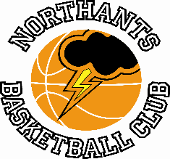

PREE RELEASE

Wins and losses for the Northants Basketball Club last weekend with pride of place going to the “Lightning” under 16 Girls who beat the Conference leaders

Stunning Under 16 Girls beat table-topping Brentwood

Under 16 Girls East Conference
Northants “Lightning” 49 -44 Brentwood “Leopards”

Led by 23 points from Luciey Caulfield the Northants Under 16 Girls pulled off a major shock when they defeated Conference leaders Brentwood “Leopards” at the Basketball Centre last Saturday. This was “Leopards” first loss of the season and came thanks to a gritty and determined defensive display from “Lightning” and of course, Caulfield’s point scoring exploits.

After their journey from Essex “Leopards” looked a little lethargic at the start of the game and were guilty of some poor defensive transition which allowed Lucie Caulfield the opportunity to score from a number of determined drives to basket. Leading 18-10 after the first quarter “Lightning” found scoring very difficult in the second quarter but were able to maintain their advantage on the scoreboard thanks to some great defensive work with Lauren Eighteen taking on the mantle of ‘shot-blocker’ in chief.

Leading 25-22 at half time “Lightning” made the perfect start to the third quarter with Caufield leading an eight, zero run. “Lightning” limited the visitors to just one basket for six minutes but “Leopards” closed the quarter with a nine, two charge to trail 32-39 going into the final ten minutes of play.

By now “Lightning” were beginning to believe that a shock win was possible but “Leopards” playing their best basketball of the game got the score back to 40-42 but short ranged jump shot from Katierly Osgood and a Caufield free throw re-established “Lightning’s” five-point advantage which they were able to hold onto aided by Brentwood missing no less than eight free throws in the final quarter of the game.

Caulfield led the “Lightning” scoring well supported by Osgood with 13 points but the key to the win was undoubtably the whole team’s defensive effort which they will be hoping to repeat when they travel to Southend “Scorpions” on Saturday

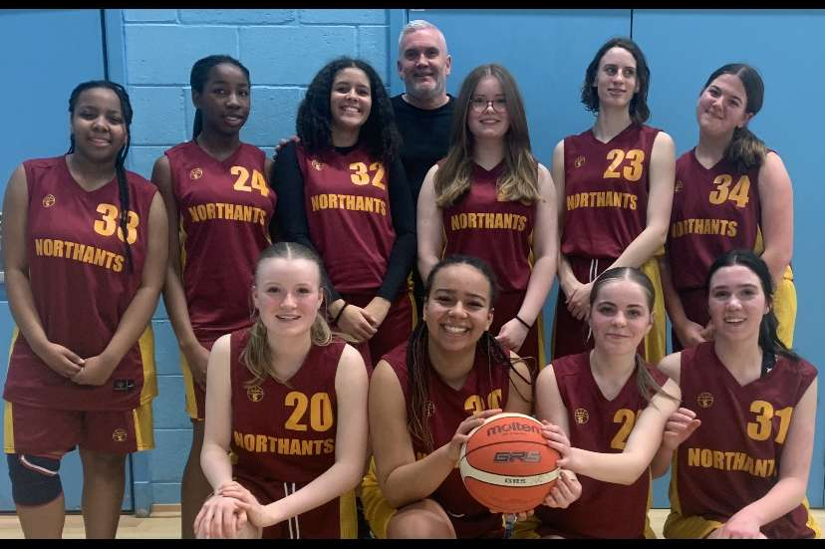

The Northants “Lightning” Under 16 Girls team after their win over Conference topping Brentwood “Leopards”

The recently established Milton Keynes Basketball Club has quickly become one of the most successful in the whole country something experienced by two Northants teams last Saturday

Under 16 Boys overwhelmed by “Breakers”

Under 16 Boys Midlands 1 Conference
Milton Keynes “Breakers” 124 - 34 Northants “Thunder”

Led by eight points including two three-pointers from Logan Ormshaw the Northants “Thunder” Under 16 Boys made a good start against the unbeaten “Breakers”. Playing at a controlled tempo “Thunder” were able to stay in touch with one of the best teams in the country but lost a little concentration at the end of the first quarter and found themselves trailing 14-21.

“Breakers” came out for the second quarter in hungry mood. They were able to stifle the Ormshaw threat and with “Thunder” losing their discipline they were overwhelmed by 44 points to 11 “Breakers” establishing a game winning 61 to 25 half time lead.

By now one or two “Thunder” heads had gone down and “Breakers” outscored their opponents 59-9 in the second half to end overwhelming winners by 124 points to 34.

In the heavy loss Logan Ormshaw with 15 was the only “Thunder” player to score in double figures.

Successive losses for Under 14 Boys

Under 14 Boys Midlands Conference
Milton Keynes “Breakers” 79 -39 Northants “Thunder”

After their loss to Conference topping Tamworth “Tigers” the previous weekend the Northants “Thunder” Under 14 Boys faced another challenge when they made the short trip to Milton “Keynes” to take on second place “Breakers”.

Despite the importance of the game “Thunder” made a lethargic start to the game and were guilty of missing several easy scoring opportunities and consequently found themselves trailing by 12 points to 17 after the first quarter. “Thunder” looked a lot better team at the tart of the second quarter and were able to close the gap to two points but then seemed to lose concentration allowing their opponents to go on a seven, zero run. “Breakers” took the quarter
15-12 to establish a 32-24 half time lead but “Thunder” were well and truly ‘in the game’.

It was “Breakers” who came out for the third quarter in the more determined mood and their defensive pressure forced “Thunder” players into errors and difficult shots. “Breakers” won the quarter 23-9 and at 55-33 it was ‘game over’ and “Breakers” proceeded to run out comfortable winners by 79 points to 39.

In the disappointing display only Oliwer Andrzekzak with 10 points was the only “thunder” to score in double figures.

Under 14 Girls too good for Deby

Under 14 Girls North 2 Conference
Northants “Lightning” 76 – 30 Derby “Trailblazers”

Playing some attractive running basketball combined with some disciplined half court offences and determined defence the Northants Under 14 Girls were able to notch a convincing win over a young Derby “Trailblazers” team.

“Lightning” made a confident start to the contest and with Campbell Spatcher and Jennifer Oamen looking impressive established a 21-8 first quarter lead. “Lightning” were able to maintain their advantage as players coming ‘off the bench’ were able maintain the team’s initiative. “Lightning” took the second quarter by 15 points to 10 to establish a 36-18 lead.

Needing a solid third quarter “Trailblazers” were overrun by “Lightning” who had seven players contribute to their 22 points as they extended their lead to 58-22. Keeping their concentration “Lightning” were able to close out for a 76 points to 30 victory their fourth win of the season which will take them into this weekend’s game against second placed Leicester “Riders” in a confident state of mined.

In the 46 point win Campbell Spatcher top scored for “Lightning” with 23 points; excellent support coming from Grace Eighteen and Queendy Yeboah who both scored 14 points

Impressive Under 15 Boys comfortably beat Oxford

Under 15 Boys Primis
Oxford “Hoops” 31 – 81 Northants “Thunder

It’s not often that a game would seem to be over by the end of the first quarter but last Sunday the Northants “Thunder” Under 15 Boys kept Oxford “Hoops” scoreless over the first ten minutes of the game while pouring in 34 points of their own. “Hoops” were able to manage eight points in the second quarter while “Thunder” increased their lead by 23 points to 57.

Leading by 57 points to eight at half time, “Thunder” knew the game was as good as over as a contest. Coach Whitney Bain was able to give all her players lots of court time and her team eventually ran out winners by 81 points 31 with their scoring led by James Kennett-Maughen with a 20 point haul. Four other “Thunder” players, Fran Guei, Jasper Roache, Rio Stephenson, and Kamil Jazwinski all made double figure contributions in the win which keeps “Thunder” top of the YBL Primis table

“Storm” edge past “Titans” in a thriller

Under 12 Mixed Region 1 League
Northants “Storm” 62 – 55 Northamptonshire “Titans”

Watched by an enthusiastic crowd the Northants “Storm” Under 12 Mixed team were able to record a ‘double’ over local rivals Northamptonshire “Titans” with a seven point win.

“Titans” edged the first third quarters 13-10 and 18-12 but “Storm” were the most impressive team in quarter two which they won by 24 points to 15. Going into the final ten minutes of play the two teams were locked at 46 points each but “Storm” had lost the services of Dominykas Jokulis. The two teams exchanged baskets at the start of the fourth quarter but a score from the impressive Clement gave “Titans” the advantage at 57-55 with three minutes to play. Clement then picked up his fifth foul of the game and showing excellent game management “Storm” closed the game out with a seven, zero run capped by a long two-pointer from Neitas Kurila.

In the hard-fought win Max Abraham had an excellent offensive game scoring 17 points the Dominici brothers both contributed ten points but Coach John Collins was quick to point out the defensive contributions made by Arlo and Kyjah Adams.

THIS WEEKEND’S ACTIVITIES

Saturday 11th March
9-15am to 10-15am “Budding Ballers”
10-15am to 11-30am “Junior Ballers”

12.00pm Under 5 Boys versus Abingdon “Eagles”
2-15pm Under 16 Boys versus Warwickshire “Hawks”
4-30pm Under 13 Boys versus City of Birmingham “Rockets”

Under 18 Boys travel to versus Gloucester “Saxons”
Under 16 Girls travel to Southend “Scorpions”
Under 12 Mixed travel to Coventry “Tornadoes”

Sunday 12th March
11-00am Under 14 Girls versus Leicester “Riders”
1-00pm Under 13 Boys versus Leicester “Riders”
Under 16 Boys travel to Milton Keynes “Breakers II”

All the home games will be played at the Northants Basketball Centre which is based at
Northampton School for Girls, Spinney Hill Road, Northampton NN3 6DG

Spectators are welcome, admission is FREE and refreshments are available.

For further information on this Press Release contact: John Collins on 07801 533 151

