NORTHANTS BASKETBALL CLUB

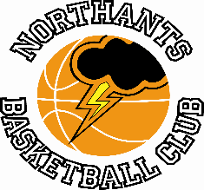

PRESS RELEASE

Assessment Programme gets underway

Following the successful programme of Summer Camps run by the Northants Basketball Club the club has now started on serious preparation for the forthcoming season. Last week Assessment and Try Out sessions were held so that coaches could have a look at the new players who have joined the Club over the summer.

The turn-out for the sessions was very pleasing and they will continue this week so there is still an opportunity for any boy or girl aspiring to play National League basketball to be seen. These players should contact the Club by email at: northantsbasketballclub@hotmail.co.uk for further information.

Last weekend the ever popular “Budding Ballers” sessions for boys and girls in Reception and Years 1 and 2 and “Junior Ballers” sessions for boys and girls in school years 3 and 4 started with over 30 boys and girls attending. Again, there are still some places available and parents of interested children should contact the Club by email.

This season the Club will be entering teams in the Youth Basketball League as well as Basketball England’s National League. The Club will also be running a programme of Casual Sessions for boys and girls who don’t get selected for team squads. This will give all the players who attend Assessment Sessions the opportunity to continue to play basketball as well as providing them with the opportunity of graduating to the team squads.

Unfortunately, it looks as if the Club will not be able to field an Under 16 Girls team. Over the summer six girls decided to play for the newly formed Daventry “Swifts” club leaving the Northants “Lightning” team short on numbers. The remaining under 16 players will be incorporated into the Junior Girls team coached by Emma Salisbury in order to give them playing opportunities

For further informati.on about this Press Release contact John Collins on +44 7801 533151

