NORTHANTS BASKETBALL CLUB
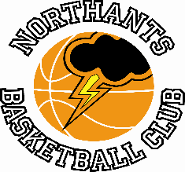

PRESS RELEASE

Club Updates

Fixture wise it was a blank weekend for the Northants Basketball Club
but there was a lot of activity off the court

National League players receive tee-shirts

Thanks to the generous sponsorship from three local firms players from all eleven national league teams have been given tee-shirts for off-court wear. The three sponsors are: Flame Fast Fire Systems, Tres Angelos Tapas Bar and Water Wizards Swim School.

Meanwhile the Club has taken delivery of three sets of reversible kit for the two Under 12 teams and the Under 14 girls. These kits have been provided by Nisa Local (Goldings).

The Northants club is extremely grateful for the support of these companies.

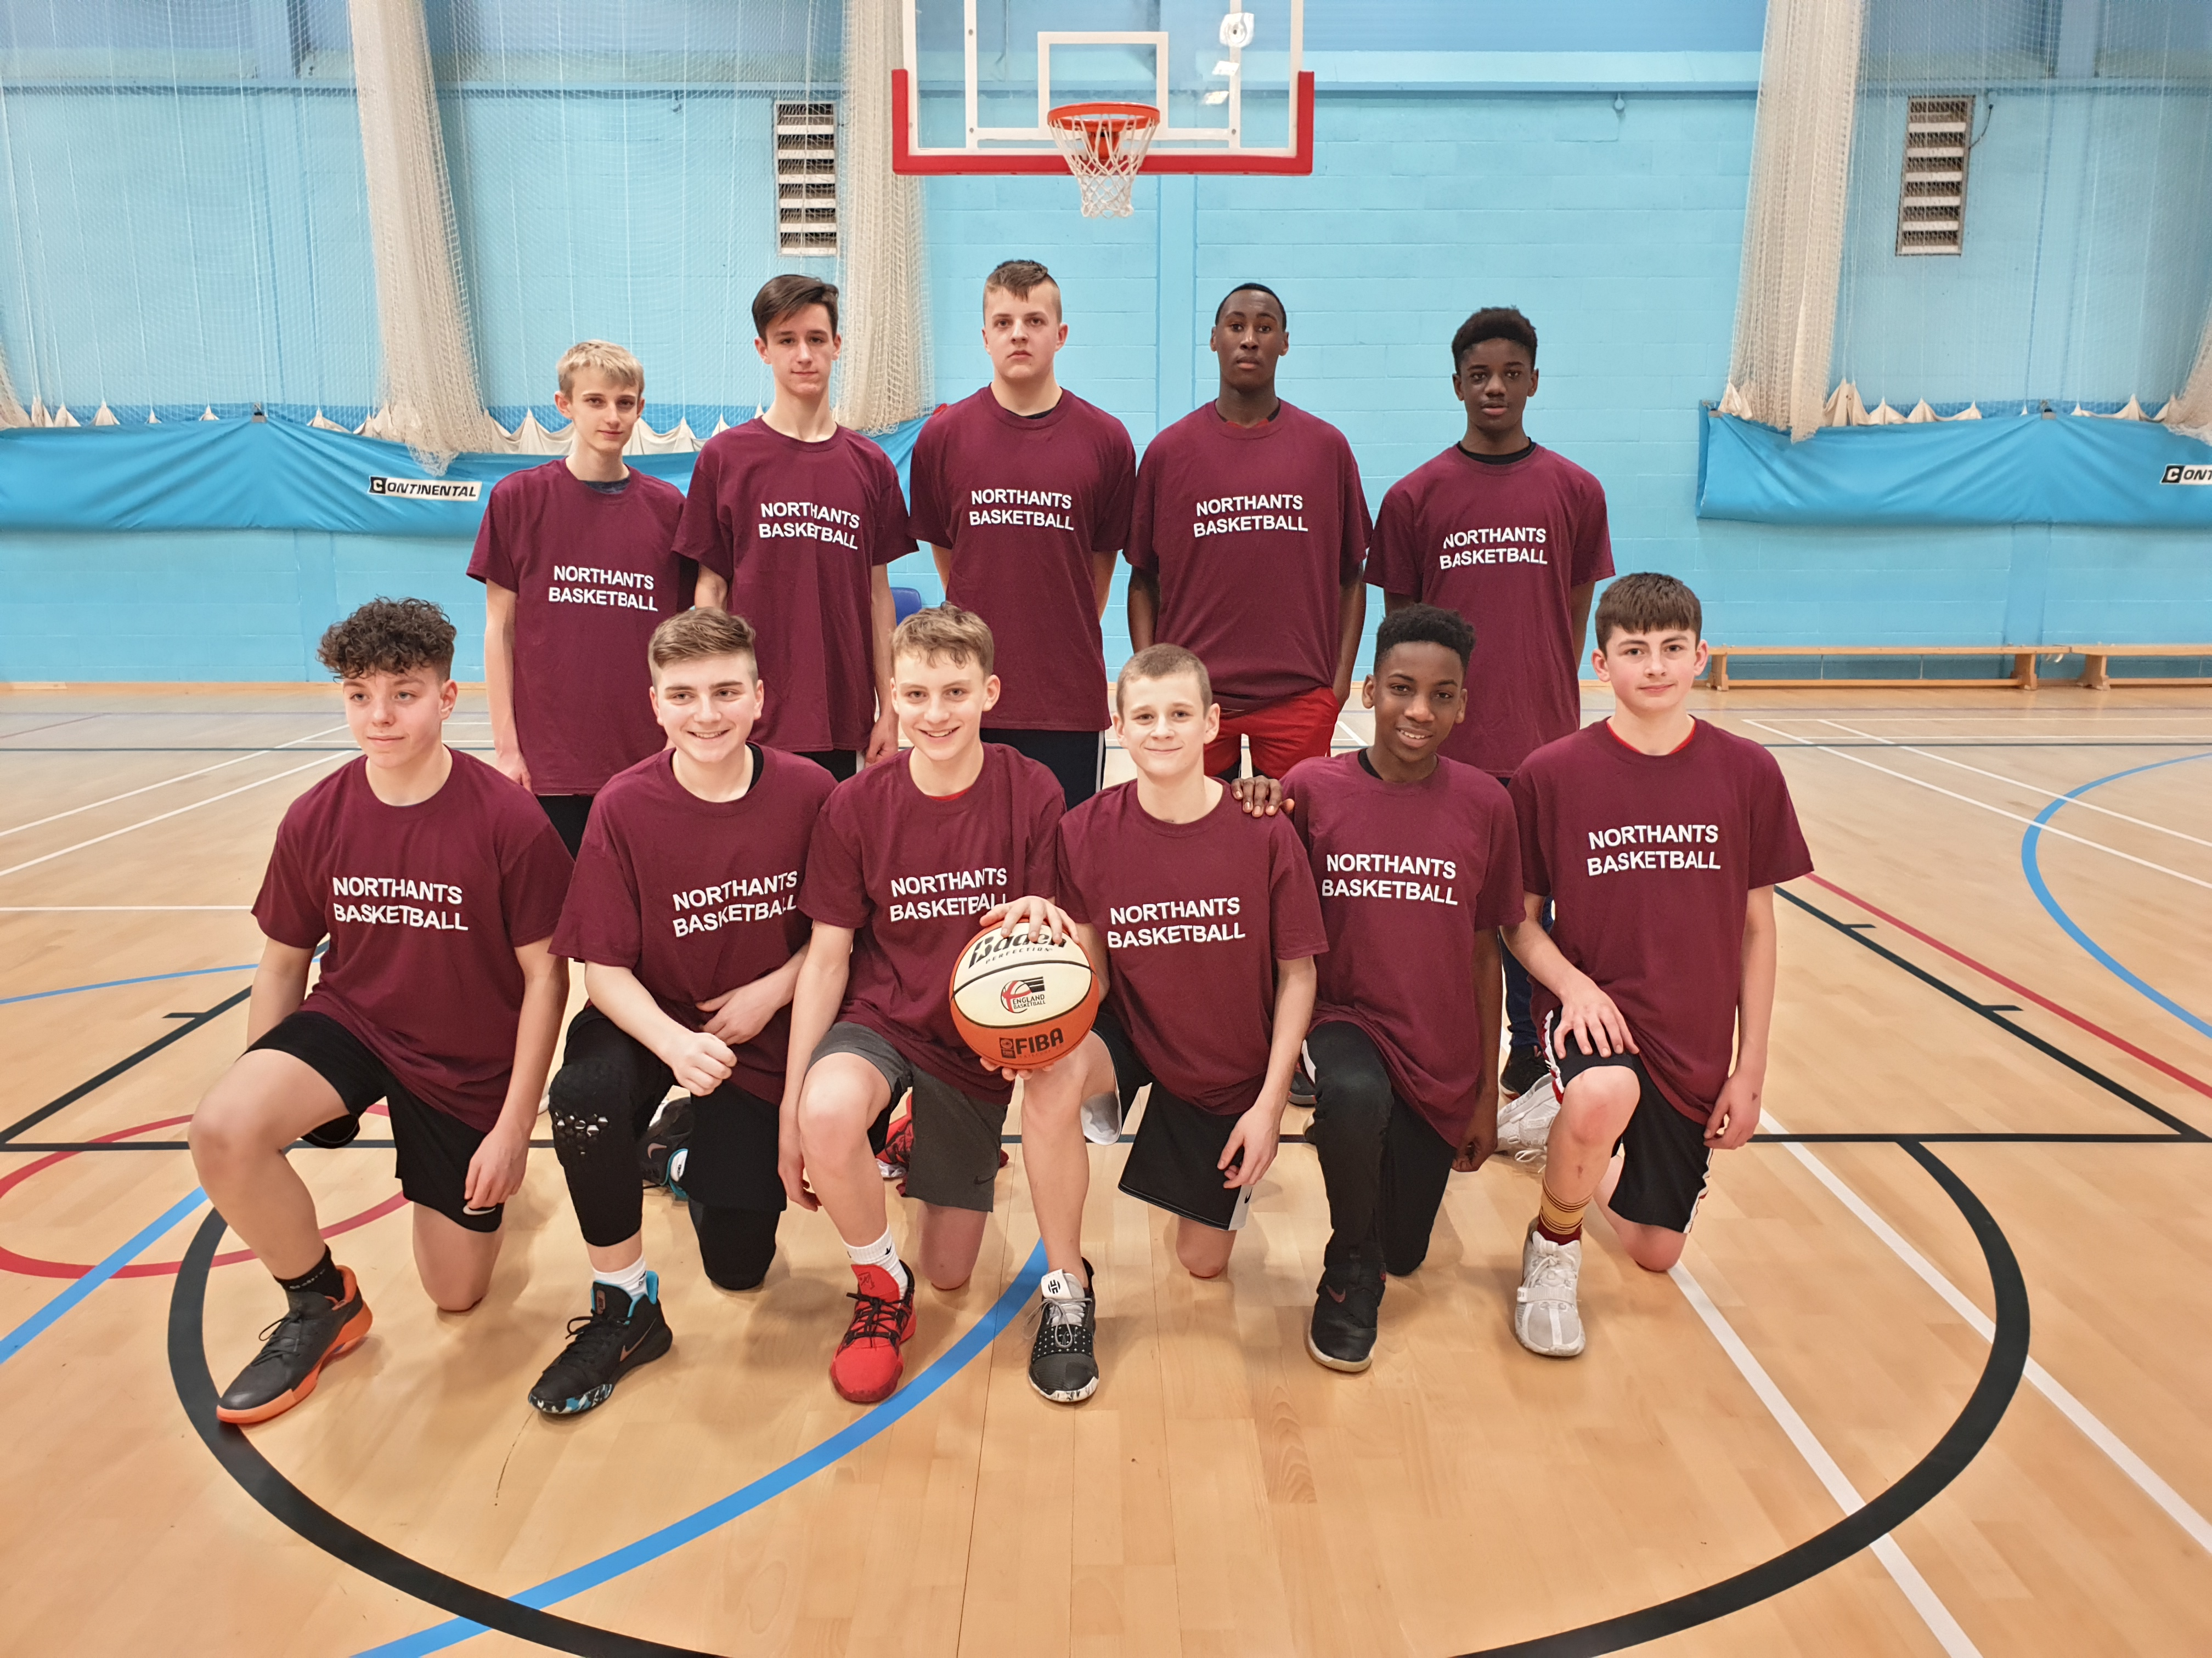

The Northants Under 14 Boys sporting their new off-court tee-shirts

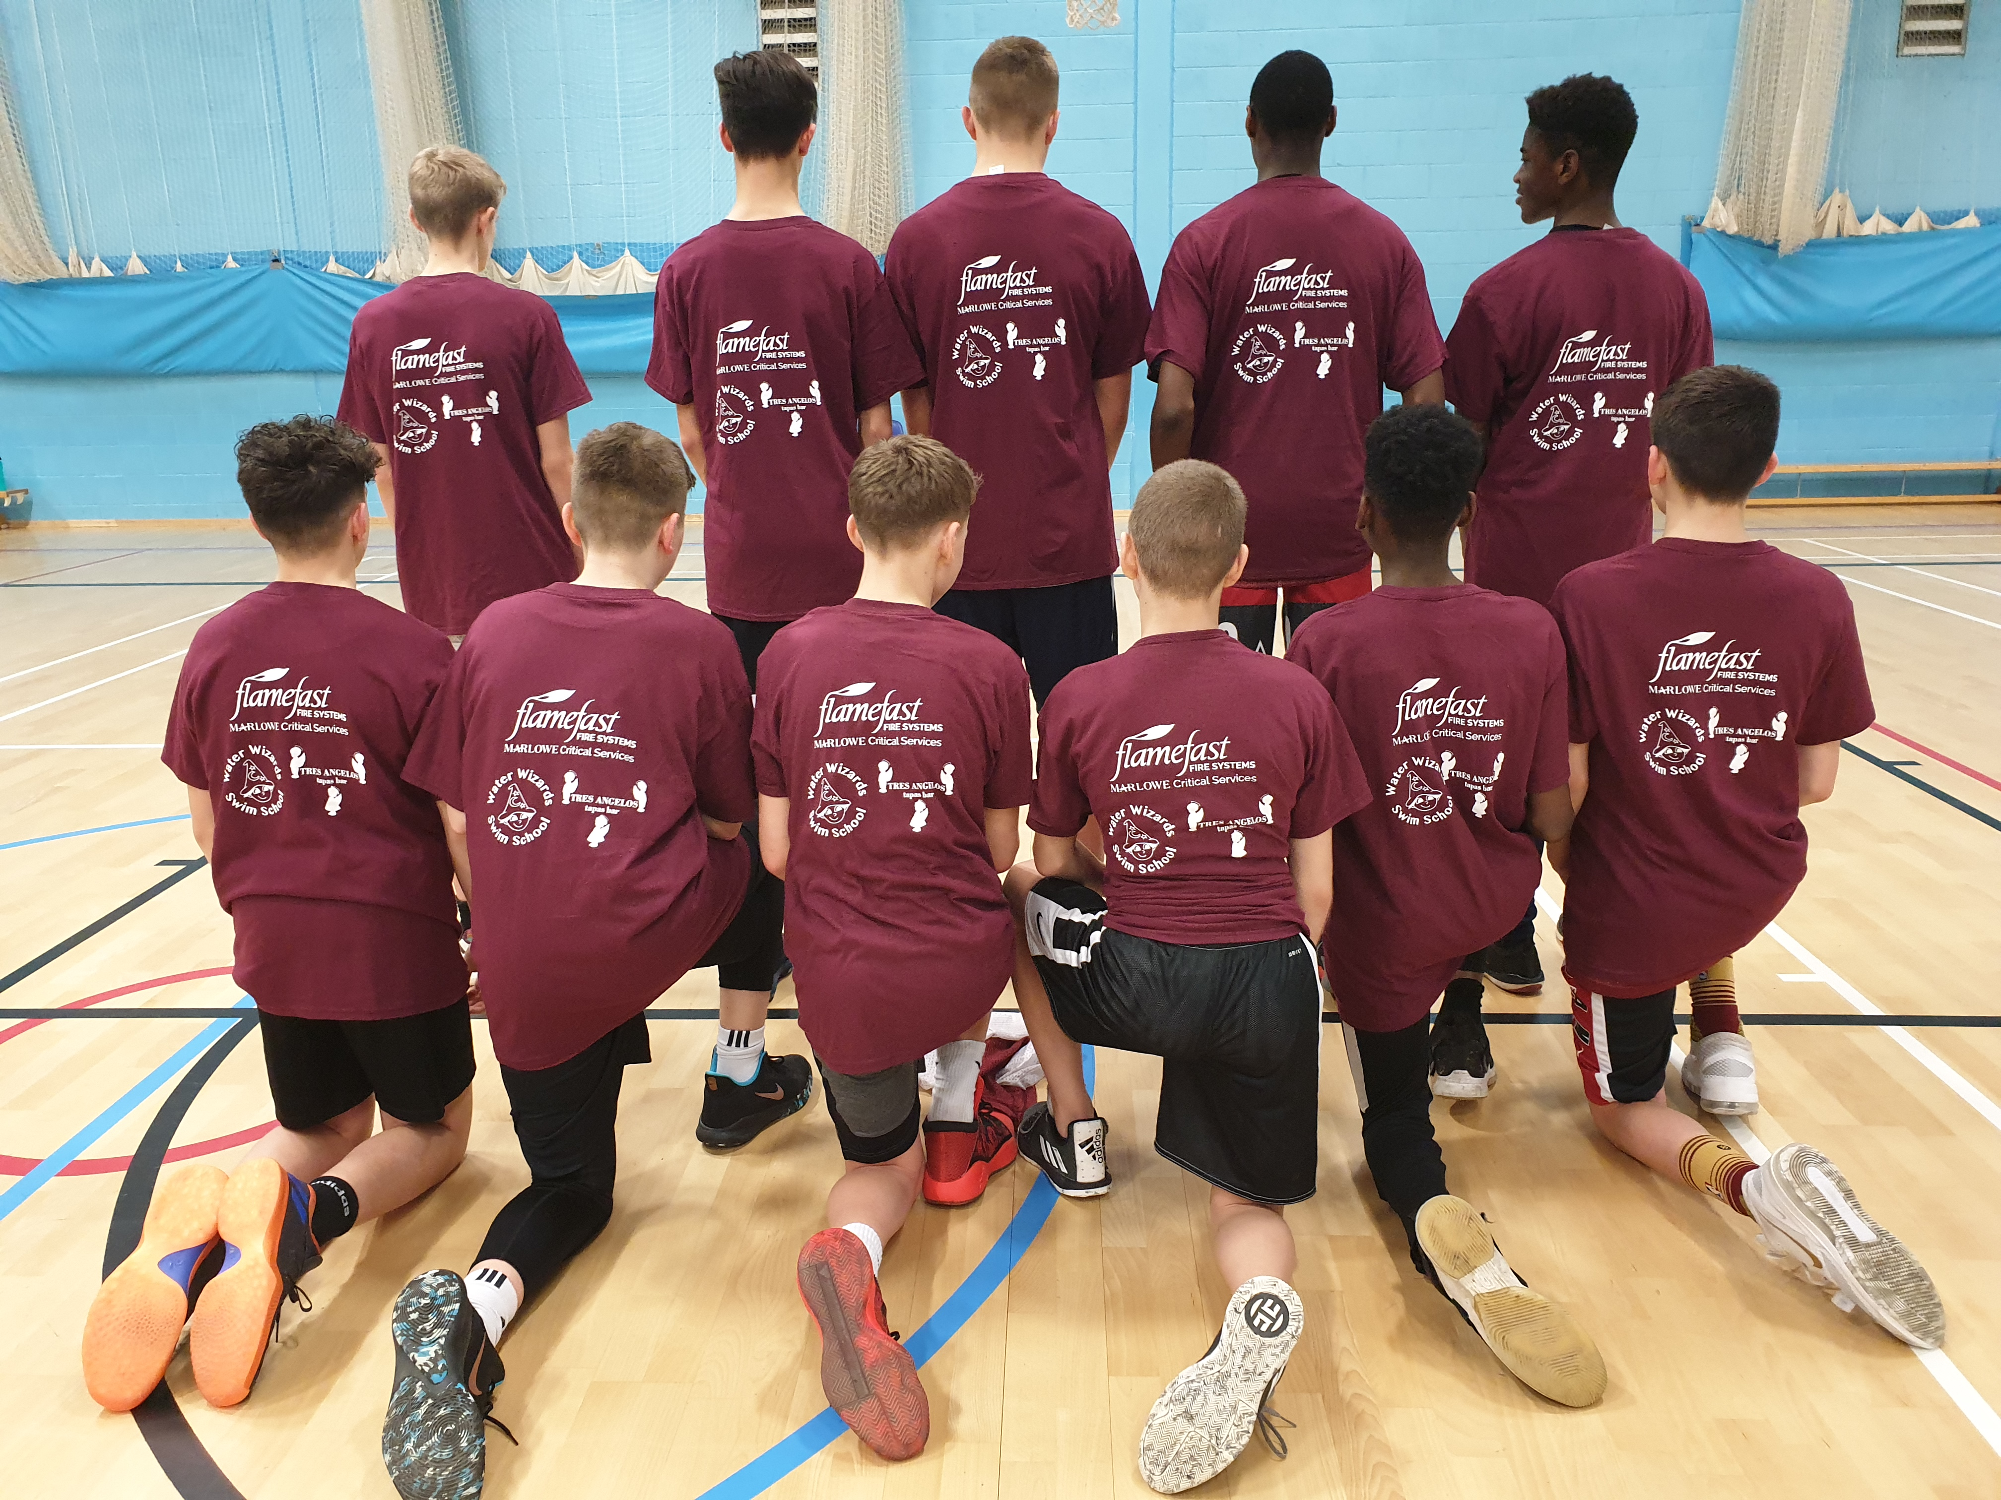

Local sponsors acknowledged on Club tee-shirts
The French Connection

The Club has established links with the Cabourg Basketball Club in Normandy, France. A Northants Lightning under 15 girls team will travel to France to play in a tournament at Easter and the Club will host an under 13 girls team from the French club in April with other English teams also invited to play in mini-tournaments.

Parker “Storm”

The Parker Storm Satellite Centre based at Parker E-Act Academy in Daventry is now up and running on Thursday and Friday evenings. Last week a group of boys from Daventry travelled to Northampton to join a Northants Thunder training session. It is the intention of the Club to continue this practice until the end of the season.

Youngest players get a chance to shine

Such has been the success of the Junior Ballers and Ballers Academy programmes that a series of games have been arranged against Shenley Scorpions. The games for Under 8, 9 and 10 boys and girls will be played at the Basketball Centre on Saturday 14th March.

THIS WEEKEND’S ACTION

Saturday 8th February
9.30am until 10.30am Budding Ballers
9.30am until 11.00am Junior Ballers
11.00 until 12.30pm Ballers Academy
12-30pm until 2.00pm Under 12 & 13 Girls session
1.00pm Under 14 Girls versus Brighton Cougars
3.00pm Under 14 Boys versus Nottingham Hoods

These activities will take place at the Northants Basketball Centre
which is based at Northampton School for Girls in Spinney Hill Road, Northampton

Junior Women travel to Derby Trailblazers

Sunday 9th February
Under 16 Boys travel to Derby Trailblazers II
Under 16 Girls travel to Bristol Flyers
Under 14 Girls travel to Brighton Cougars

For further information contact John Collins on 07801 533 151

