NORTHANTS BASKETBALL CLUB

PRESS RELEASE

No unlucky thirteen for Under 14 Girls

Under 14 Girls South Conference
Northants Lightning 84 – 50 Southend Rockets
A stunning first half performance by Lightning virtually put the result of this South Conference game beyond doubt as the home team charged into a 42-16 lead. During those two periods of play Southend found it difficult to cope with Lightning’s aggressive defence and fast break offences orchestrated by Latisha Betsy and Athena Thompson. In those two periods ten Lightning players made scoring contributions with Mia Gajaga particularly catching the eye.

Rockets were far more competitive in the third and fourth quarters with Lightning being guilty of playing some loose defence as well as missing an alarming fourteen free throws. Despite these lapses the final result was never in doubt as Lightning cruised to their thirteenth consecutive win led by 17 points from Thompson. Good support came from Betsy and Gajaga while Keris Ndubisi scored ten of her 12 points in the final quarter.

This weekend Lightning travel to Croydon to take on Haris Federation Knights in a top of the table clash.

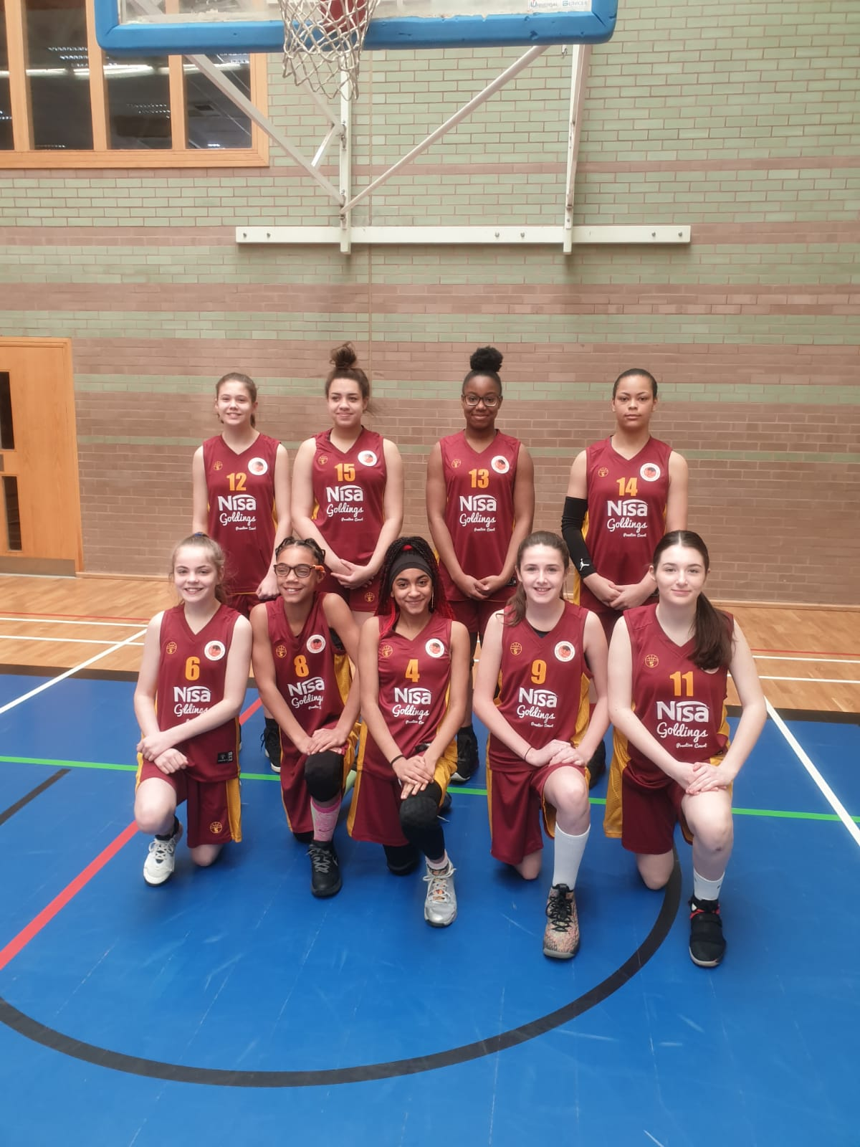

The Northants Lightning Under 14 Girls in their new Nisa Local sponsored kit
Under 16 Girls have no problem in bringing Rockets down to earth

Under 16 Girls Central Conference

Northants Lightning 82 – 39 Reading Rockets

Lightning Under 16 Girls entertained winless Reading Rockets last Saturday and turned in a thoroughly professional performance, finally winning by a convincing 43 points.

Lightning started the game in scintillating style rushing out to a 10-zero lead thanks to some excellent defence and effective fast breaks. After six minutes Lightning decided to relax their efforts and Reading responded with six unanswered points to close the gap to 10-6 after the first period of play. Lightning came out for the second quarter in aggressive mood and their pressure defence resulted in Rockets collapsing in the closing four minutes of the period. During those four minutes Lightning outscored Rockets 16-six with Fiona Arthur and Dina Kosnikovska scoring at will.

Leading 39-17 at the half stand-in coach Karen Goodrich set the team a target of winning by 40 points and the players responded well in the third period with the defensive efforts of Ruby Harkins and Lucie Wilson-Gray forcing a number of turn overs leading to easy scores. Lightning took the period 18- six to establish an unassailable 57-23 lead but were then guilty of relaxing and allowing Rockets to outscore them 12-9 at the start of the final stanza. Goodrich had stern words for her players and they responded with a 16- four charge in the final four minutes against tiring opponents, to reach the target set for them.

In the 82 to 39 win Kosnikovska top scored well supported by Arthur while Ellouise Gregory and Oti Ata both scored in double figures. Wilson-Grey racked up a double figure tally of assists and rookie Mia Gajaga turned in a solid performance at both ends of the floor.

Brave Under 16 Boys go down to Hoods

Under 16 Boys East Midlands Conference

Nottingham Hoods 78 – 70 Northants Thunder

A short-handed Thunder Under 16 Boys team travelled to high-flying Nottingham Hoods expecting a tough physical game and they certainly got it. Within the first few minutes of the game they lost the services of Tom Greenfield with a knee injury and early in the second half had to sit out Benas Maldutis after a heavy collision.

Earlier in the season Thunder had lost by almost points to Hoods so a difficult task was made even harder with the physical nature of the game. In the event they responded magnificently none more so than Ashley Kitchen who rained in 23 first half points including five three-pointers most of them in transition. Defensively Thunder were battling hard and with Luke Desborough, Fareed Issifu and Nathan Pluck securing vital rebounds were able to get into their running game.

Leading 41-36 at half time Thunder knew that Hoods would be paying close attention to Kitchen and with their ‘go to’ player shackled several players were guilty of trying to take matters into their own hands. With Thunder losing their offensive discipline Hoods were able to take the period 22-16 and establish a one-point lead at 59-57.

Needing a massive effort in the final period and with Kitchen continued to be shackled, Thunder just didn’t ‘have the legs’, and despite the efforts of Desborough who scored eight points Hoods were able to take the game by 78 points to 70.
‘
In the eight points defeat Kitchen top scored and only Desborough and Kris Dambrauskas, who had a fine game in the back court were able to make double figure contributions.

Thunder coach, John Collins and most of the Hoods supporters thought the game had been over-physical but this wasn’t a view shared by the Hoods coach.

Below par Under 14 see off Warriors

Under 14 Boys East Midlands Conference
Leicester Warriors I 39 – 79 Northants Thunder

Thespians would have us believe that a good dress rehearsal is always followed by a poor first night and so it proved for Thunder Under 14 Boys. After an impressive practice two days earlier, they started the game against the Leicester Warriors first string in lethargic mode missing numerous easy scores as well as being profligate from the free throw line.

Despite these flaws Thunder managed to establish a 35 points to 24 half time lead thanks to some disciplined defensive play. This defensive effort continued in the second half and with Hugo Dutton Jordan Gbanja, and Rapolas Radivicius dominating the rebounding, Thunder were able to get into their running with Benas Maldutis and Jack Lemon controlling the game well. Thunder scored 44 points in the second half whilst conceding just 15 to run out winners by 79 points to 39.

Nine players contributed to Thunder’s final total led by Gbanja and Maldutis but there was a feeling at the end of the game that victory had come as much from physical superiority as basketball skill. This weekend Thunder face two teams from the lower end of the Conference before they take on table-topping Leicester Dynamite.

Under 13 Girls have a tough day at the offence

Under 14 Girls Regional Pool 2
Braintree Blue Devils 75 – 32 Northants Lightning

Cambridge Cats 58 – 16 Northants Lightning

With a journey taking over 3 hours. Northants Lightning under 13 girls were hardly in the best shape to contest their latest round of matches in the National under 14 competition. They found themselves up against two teams made up of physically bigger players and with the match officials allowing much more contact than would be expected at this level, these were two very difficult games.

But, as always, the young Northants players gave great effort despite the very difficult circumstances. Time and again they found themselves pushed off of the ball as their superior skills were nullified by what, on most days, would be deemed to be illegal contact.

In the defeats, Year 8 students Ella Smith and Tiegan Burrows performed very credibly to lead their team’s scoring.

Under 12 Girls keep their unbeaten record

Under 12 Regional Pool 2
Norfolk Angels 7 – 32 Northants Lightning
Brentwood Fire 17 – 50 Northants Lightning

For the second day running, Northants Lightning faced a lengthy and difficult journey, this time to Norfolk, for just their second outing of the season. Missing several players, this looked like being another tough day for the younger Lightning team.

The game against the host team saw Northants make a positive start, scoring eight of the first ten points scored. Despite the game being shortened due to Lightning’s travel delays, the team were able to maintain the momentum and completed a surprisingly comfortable 32-7 win.

The second game was against Brentwood Fire, who have an excellent reputation in producing very good young players. But Northants were determined to maintain their unbeaten record in the competition. An outstanding first half saw them lead 24-7 and despite the primary school pupils playing the majority of the final two quarters, Lightning ran out winners by 50 points to 17.

In the two matches, Alannah Major and captain Jessica Jesu dominated but this was an excellent performance by all the young ladies.

THIS WEEKEND’S ACTION

Saturday 7th March
9.30am until 10.30am Budding Ballers
9.30am until 11.00am Junior Ballers
11.00am until 12.30pm Boys Ballers Academy (Boys & Girls)
1.00pm Under 18 Girls versus Wiltshire Demons
Under 13 Girls versus Sussex Bears
2.30pm Under 13 Girls versus Sussex Bears
4.30pm Under 16 Boys versus Ilkeston Outlaws

All these activities and games will take place at The Basketball Centre which is situated at
Northampton School for Girls, Spinney Hill Road, Northampton NN3 6DG

Spectators are most welcome, and admission is FREE

Under 14 Girls travel to Haris Croydon
Under 14 Boys travel to Mansfield Giants

Sunday 8th March
11.00am Under 14 Boys versus Rutland Thunders
1.00pm Under 16 Boys versus Leicester Dynamite

These games will be played at The Basketball Centre

Under 16 Girls travel to Bracknell Cobras
Under 12 Boys travel to Leicester to play Dynamite and Riders Red

For further information contact John Collins on 07801 533 151

