NORTHANTS BASKETBALL CLUB

PRESS RELEASE

With a total of 12 games over the two days this was the busiest weekend of the 2019 / ’20 season.
It is a testament to the strength of the Club that all teams went on court with a full compliment of players and all 12 teams were supervised by a fully qualified coach and many of the teams also had a team manager in attendance.

Impressive double for Cadet Boys

Under 16 Boys East Midlands Conference

Northants Thunder 104 – 36 Ilkeston Outlaws

Stand-in coach, Brad Hughes asked his team to make a statement at the beginning of this game to shake off the disappointment of the previous weekend’s narrow loss against Nottingham Hoods. The team responded magnificently and on the back of some excellent pressure out of their trapping zone defence and ten points from Tom Greenfield rushed out to a 29-six lead after the first period of play.

Thunder maintained the pressure in the second period and with a the score line standing at 50-19 at half time the game was as good as over as a contest.

The team have spent a lot of time talking about standards and thinking more about process than outcome so the third period was all about doing things properly in preparation for the next day’s game against Leicester Dynamite. Once again the team responded well and with seven players contributing Thunder outscored their opponents 35-seven, displaying some impressive ball movement and perimeter shooting.

With the outcome of the game a foregone conclusion Thunder were guilty of some untidy play in the final stanza but still cruised to a 104 to 36 victory with Greenfield and Ashley Kitchen leading the scoring excellent support coming from Kris Dambrauskas and Dylan Dominici.

Northants Thunder 67 – 53 Leicester Dynamite

Less than 24 hours after their comfortable win over Ilkeston Outlaws, Thunder were back on court against Leicester Dynamite. Coach John Collins considered the away win over Dynamite earlier in the season one of the team’s best performances of the season. On that occasion Dynamite’s talented Okposio had taken Thunder for 22 points so a big defensive effort was called for in this game. Dynamite had also been well served by speedy guard Thomas who single handed had destroyed Thunder’s pressure defence.

Both teams started the game in nervous fashion with Thunder struggling to penetrate the visitors zone defence. They were also being called for fouls in their trapping zone defence which the previous evening had been deemed perfectly legal. Luckily for Thunder, Dynamite were not efficient from the free throw line but at the end of the first period the Leicester team lad 16-13.

The game continued in cagey fashion at the start of the second period before Thunder made a tactical switch to a half court defence which had the effect of totally nullifying Dynamite’s offensive effort. Thunder outscored their opponents 11-2 over a five minute period to take a 28-22 half time lead.

Thunder’s defensive effort was maintained in the third period, but it proved not to be to the liking of the match officials as the foul count mounted against them. The team’s momentum was maintained by the combined efforts of Benas Maldutis and Jordan Gbanja the two rookies on the team. Maldutis connected with two three-pointers and Jordan with a brace of spinning put backs as Thunder edged the period 20-17 to extend their lead to 48-39.

Collins warned his team against complacency but after a score from a step through move from Okposio, Thunder were able to embark on a 13-4 charge to put the result beyond doubt with two jump shots from Fareed Issifu being crucial. Leading 63-45, not for the first time this season Thunder’s clock management over the closing three minutes was poor allowing Dynamite to close the gap but the final result was never in doubt.

In the 14 point win all ten Thunder players scored led by Ashley Kitchen who also put in a great defensive shift restricting Okposio to just a dozen points. Several other factors contributed to the win not least of all the rebounding of Luke Desborough and Natham Pluck.

This weekend Thunder face a very tough challenge when they travel to Mansfield Giants who beat them by two points earlier in the season

Under 14’s stifling defence too much for Giants

Under 14 Boys East Midlands Conference
Mansfield Giants 22 – 107 Northants Thunder

After seven minutes of this East Midlands Conference game Giants were well in touch at 9-10 with Thunder being guilty of missing a number of easy scores as well as seven free throws. It was certainly a case of ‘leaving your game on the bus but to their credit to their credit they raised their efforts over the next 33 minutes. During those 33 minutes Thunder restricted their opponents to just 13 points despite being forced by the rules, to take off their ‘press’.

On offence Thunder were irrepressible with no less than eight of their players making double figure contributions led by Hugo Dutton. As well as Thunder’s defensive effort the 14 point, eight rebound contribution by David Utubor Irabor was very encouraging.

The team are without a game this weekend and their next fixture is against Leicester Dynamite, a fixture which is likely to decide the destination of the Conference title.

Under 14 Boys Regional League

Braintree Blue Devils 53 – 29 Northants Thunder Too

Expecting to be playing games two and three in their latest tournament Thunder were rushed into playing the first game because the Kings Lynn coach had not arrived on time.

With insufficient preparation time Thunder were guilty of poor passing and a number of turnovers gave Blue Devils numerous easy scores as they established an early lead. Thunder continued to struggle throughout the first half and they weren’t helped by poor free throw shooting.

The second half saw some good play from David Utubor and Jake Muxlow but the final result was never in doubt as the powerful Braintree team ran out comfortable winners.

Kings Lynn B.C. 32 -31 Northants Thunder Too

It was a stronger Kings Lynn side that took the court than the one when the side last met. Throughout the game Thunder struggled to come to terms with some of the referees decisions and more particularly with the home side’s defence which was looking suspiciously like a zone.

Going into the last period Thunder trailed 19-24 but a big push gave them the lead with less than three minutes to play. Thunder were able to hold out for what they thought was a win but a late discovered score sheet error gave Kings Lynn the win.

This is a very young team and Coach Brad Hughes has been delighted by the progress they’ve made.

No joy for Under 12 Boys in Loughborough

Under 12 Boys East Midlands Conference

Thunder’s final tournament of the season ended with two disappointing performances

Leicester Riders 24 – 54 Northants Thunder

Thunder’s first game saw Riders dominate the encounter with a powerful display of offensive rebounding and aggressive defence. Thunder’s response lacked physical commitment and energy and their teamwork fell apart under the pressure. Throughout the game Riders were able to convert Thunder turnovers with easy points.

In the heavy defeat Lennon Martin and Tafari Pryce scored six points apiece but it was James Kennett-Maughan who remained steadfast on offence and hard working on defence setting an example his team mates failed to copy.

Leicester Dynamite 33 – 28 Northants Thunder

Thunder almost stole victory against Leicester Dynamite, reversing an 8-17 deficit to a one point lead late in the game. When disciplined teamwork was most needed Thunder played as individuals forcing up poor shots when taking care of the ball and patience were most needed. These lapses allowed Dynamite the opportunity to steal the win, an opportunity they gleefully seized.

No demons for Junior Women against Wiltshire

Under 18 Girls National Conference
Northants Lightning 69 – 36 Wiltshire Demons

Double figure hauls from Poppy Barnett, Dina Kosnikovska, Lucy Needham, and Lucie Wilson Gray saw Lightning junior women to a comfortable win over Wiltshire Demons last Saturday.

Lightning made a sluggish start to the game but after a time out raised the tempo of their game to take the first period 22-eight. They were guilty of relaxing their efforts in the second period but by half time had extended their lead to 36-18 thanks to an impressive defensive effort.

That lead was extended by a further four points in the third period of play then in the final stanza totally dominated the tiring Demons. A 16-five charge saw Lightning home to a convincing 33 points win that keeps them in third place in the National Conference.

This weekend the team are ‘on the road’ when they travel to London Warriors on Saturday then take on Demons again after an overnight stay in Swindon

Under 16 Girls Central Conference

Bracknell Cobras 62- 63 Northants Lightning
(52-52)

For their penultimate fixture of the season Lightning under 16 girls made the lengthy journey to Bracknell Cobras. Missing several players Lightning gave fourteen year old Ashia King her debut at this level.

The home side made a strong start as Lightning’s lack of cohesion was evident and they trailed 11-20 after the opening period of. Northants re-grouped during the break and a 15-4 run tied the game at 26 all after six minutes of the second period. Cobras were able to edge in front over the next four minutes and led 34-32 at half time.

The start of the third period was disastrous for Lightning as they failed to capitalize from a number of easy scoring opportunities. Luckily, Cobras fared no better and with ten minutes of the game remaining led by one point at 42-41.

Those final ten minutes were certainly not for those of of a nervous disposition as the home crowd did everything in their power to will their team to victory. With three minutes of the game remaining Cobras led by four points, but 13 year old Brooke Leo came up with two huge shots to take the game into overtime.

The extra five minutes looked to be going in the hosts favour as they opened up a 60-54 lead midway through the extra period, but Lightning would not be denied. With the crowd screaming, Lightning scored nine of the last 11 points to record a famous victory.

Once again, Lightning were led in scoring by captain Dina Kosnikovska and Lucie Wilson-Gray but this was a superb team performance typified by the fighting qualities of Oti Ata with her best game of the season, Ruby Harkins, Athena Blowes and Kyla Soya - Bongay who all gave a total effort to the cause.

All good things must come to an end

Under 14 Girls South Conference
Harris Federation Knights 76 - 47 Northants Lightning

Game number fourteen proved to be one step too far for the Northants Lightning under 14 girls as their unbeaten run came to an abrupt end against Harris Federation Knights.

After a traumatic journey to Croydon Lightning made a surprisingly good start to the game and after the first period of play were tied at 20 all. The second period was an attritional affair which lightning just edged 10-seven to take a 30-27 lead into the locker room at half time.

Knights came out for the third period in determined mood and it soon became obvious that Lightning would have to battle hard to retain their unbeaten record. Despite the efforts of Letisha Betsy, Aishia King and Athena Thompson the home side took the period 27-13 thanks to some efficient transitional offence, to lead 54-43 going into the final stanza. With a lot of vocal support and Lightning’s defensive effort hampered by an injury to Mia Gajaga; Knights overwhelmed Lightning 22-4 in the final ten minutes to take a comfortable 76 points to 47 victory.

This was only Lightning’s second defeat of the season and they are still in with a chance of taking the Conference title as Harris have lost three games, but the team will have to regroup quickly before their next game in a fortnight’s time.

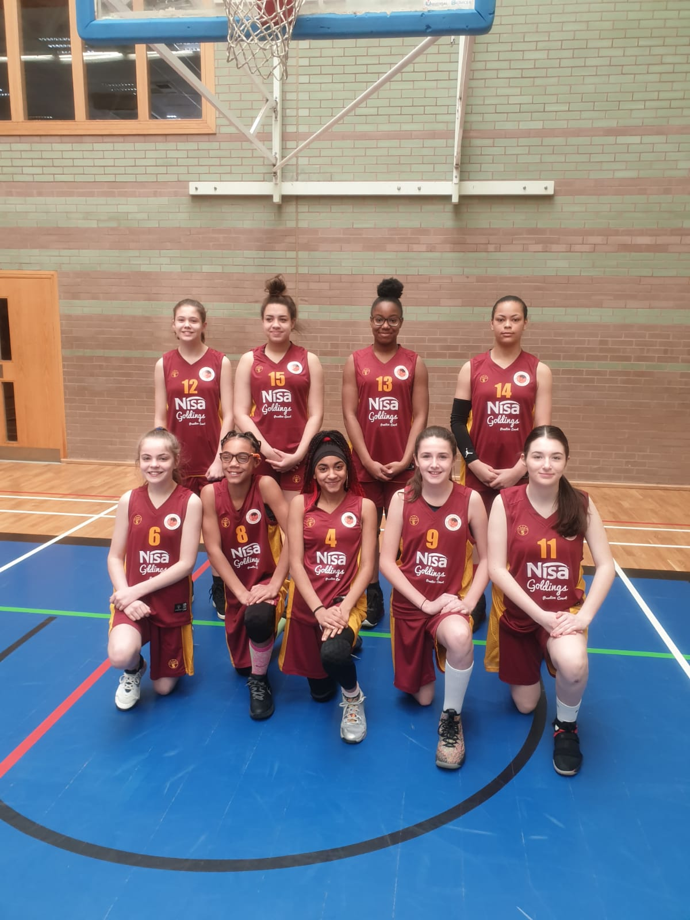

The Northants Lightning Under 14 Girls in their new Nisa Local sponsored kit
Gutsy Under 13 Girls have another tough day at the office

Under 14 Girls Regional Pool 2

Northants Lightning under 13 girls had their first home game in some time with two matches against Sussex Bears. Lightning were missing a number of players meaning half the team were 12 years old, or younger.

Northants Lightning 42 – 51 Sussex Bears

Sussex’s very aggressive defence caught Lightning unaware as the visitors scored the first nine points of the game and had their foul shooting been more accurate they could have put the game ‘out of sight’ in the first period.

The very young East Midlands side battled bravely throughout the rest of the contest, despite the loss of Ella Smith to illness. From a 28-17 half time deficit the margin was reduced to just seven points with one period of play remaining and although they could get no closer the loss by 51 points to 42 showed the promise of the young ladies

Northants Lightning 44 – 49 Sussex Bears

After a short break the two teams locked horns again and once again the eight players from Sussex (the rules dictate that each team should have ten participants) took the initiative leading 21-12 at the end of the first period; and when they extended their lead to 34-17 the game looked to be as good as over.

To the delight of a big crowd Lightning found huge resolve and mounted a spirited comeback and led by Tiegan Burrows and Jess Jesu they fought back but still trailed by 40 points to 28 going into the final stanza. Alannah Major and Lucie Caulfield found their scoring touch and when Jesu made a pair of free throws the hosts led 44-43. In the end Sussex’s greater experience prevailed and the Bears were able to score the final six points to clinch a narrow win but this was a performance far beyond the years, for the Northants girls.

THIS WEEKEND’S ACTION

Saturday 14th March
9.30am until 10.30am Budding Ballers
9.30am until 11.00am Junior Ballers
11.00am until 12.30pm Boys Ballers Academy (Boys & Girls)
1.00pm Under 12 Girls versus Ipswich Bobcats
Under 8’s versus Milton Keynes Scorpions
2.15pm Ipswich versus Oaklands Under 12 Girls
Under 9’s versus Milton Keynes Scorpions
3.30pm Under 12 Girls versus Oaklands Wolves
Under 10’s versus Milton Keynes Scorpions

All these activities and games will take place at The Basketball Centre which is situated at
Northampton School for Girls, Spinney Hill Road, Northampton NN3 6DG

Spectators are most welcome, and admission is FREE

Under 18 Girls travel to London Warriors
Under 16 Boys travel to Mansfield Giants
Under 16 Boys (Regional) play Barking & Dagenham and Bury St Edmunds

Sunday 15th March
10.30am until 4pm G.B. Masters practicing at The Basketball Centre

Under 18 Girls travel to Wiltshire Demons
Under 13 Girls travel to Milton Keynes Scorpions

For further information contact John Collins on 07801 533 151

