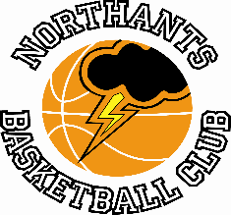

PRESS RELEASE

Northants Basketball Club to stage three Free Basketball Camps

With Covid restrictions being eased at the end of the month and organised, outdoor sport being permitted, the Northants Basketball Club in partnership with Basketball Northants has decided to organise three Community Outdoor Camps. The Camps will be held on the outdoor courts at Northampton School for Girls on Tuesday 6th April and there will be no charge to participants.

The three Camps are:
Primary Schools Camp for boys and girls in school years 4, 5 and 6 10-00 am until 11-30am

“All Girls” Camp for girls in school years 7 to 11 inclusive from 11-30am until 1-00pm

Boys Camp for boys in school years 7 to 11 inclusive from 1-30pm until 3-00pm

The Camps will be supervised by fully qualified coaches including Basketball England ‘Aspire’ coach Kim Thompson and the Girls Camp will be part of the “All Girls” Programme. Karen Goodrich the administrator of the Northants Club is an ambassador for this national initiative.

All activities on the Camps will be Covid-safe with full screening before the camps start and regular sanitising of participants and equipment.

The Camps are a joint initiative between the Northants Club and Basketball Northants and are an attempt to help get basketball re-started in the community. There will be no charge for the camps, but players must register by e-mailing the club at northantsbasketball@hotmail.co.uk, through the club’s website northantsbasketballclub.net or by messaging on the Club’s Facebook page to express an interest. Numbers will be limited in order to comply with Basketball England Return to Play guidelines.

For further information about this Press Release contact John Collins on 07801 533 151

