NORTHANTS BASKETBALL CLUB

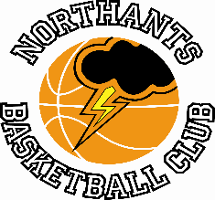

PRESS RELEASE

The busiest weekend of the season saw the usual ‘ups’ and ‘downs’ for the Northants Club with pride of place going to the Cadet Boys who clinched the Midlands Conference title.

Cadet Boys win the Midlands Conference

Under 16 Boys Midlands Conference
Leicester “Riders II” 30 – 55 Northants “Thunder”

Earlier in the season the “Thunder” Under 16 Boys had comfortably beaten the “Riders” second string but with the team needing a win to clinch the Midlands Conference title nerves seem to set in and despite looking the superior team in the first quarter they found scoring difficult and could only establish a narrow 14-7 lead after the first ten minutes of play.

Scoring was no easier for “Thunder” in the second quarter during which time they could add only a further 12 points but a superb defensive effort restricted “Riders” to just six points but there was still a nervous tension in the locker room at half time despite holding a 26-13 lead.

Nine points from Benas Maldutis in the third quarter settled those nerves as “Thunder” extended their lead to 43-24 and their was no way back for the Leicester outfit as “Thunder” closed out the game at 55 points to 30; Maldutis leading their scoring with 18 points, important contributions coming from Jack Lemon and Rapolas Radavicius.
Report compiled by Jack Lemon

As Conference champions “Thunder” will advance to the Promotion Play Offs where they will face one of the lower placed team from the North Premier League on 2nd and 3rd April; Thunder’s opponents in this first Play Off game have yet to be established

Junior Men are second best against “Warriors”

Under 18 Boys Midlands 2 Conference
Leicester “Warriors” 63 – 59 Northants “Thunder”

The Northants Junior Men made the short journey to Leicester in the hope of recording a double over “Warriors” but with their compliment of Under 16 players missing they knew it was gong to be a tough ask and so it proved.

“Thunder” made a nervous start to the game and could only manage 11 points in the first ten minutes of play while “Warriors” scored 21. Things got no better in the second quarter with “Thunder” managing only another 11 points but some determined defence kept “Warriors” to 15 but at 22-36 down their was a mountain to climb for the Northants boys in the second half.

The arrival of their Under 16 contingent fresh from their win over “Riders” seemed to boost “Thunder” and they took the third quarter 13-9 to reduce the deficit to just ten points. “Thunder gave it their all in the final quarter which they won 24-20 but it wasn’t quite enough to secure the win.

In the four point loss “Thunder’s” scoring was led by Fareed Issifu with 17 points excellent support coming from Benas Maldutis and Dylan Dominici with 14 and 10 points respectively

Report compiled by Tom Greenfield

Gutsy Junior Women lose to “Rockets”

Junior Women’s (North Conference)
Northants “Lightning” 42 – 51 City of Birmingham “Rockets”

A few weeks ago, the Northants Junior Women were beaten by over 30 points by an athletic and very physical Birmingham team but it was a very different story at The Basketball Centre least Saturday. “Lightning” eventually lost by nine points but they were competitive throughout the contest. They will look back on a poor finish to third quarter during which time they were outscored 9-zero; and missing six free throws during the last three minutes of the game.

They will however, be proud of the fact that they kept the talented “Rockets” team who are Conference champions elect to their lowest points total of the season.

In the narrow defeat the “Lighting” scoring was led by Dina Kosnikovska with 19 points but Coach Emma Salisbury was quick to praise the whole team for their efforts.

Wonderful Bates can’t prevent defeat for Under 15 Boys

YBL Under 15 Boys Primis League
Leicester “Riders” 63 – 49 Northants “Thunder”

A superb effort from Thomas Bates with 20 points and double figure rebounds wasn’t enough to prevent the Northants Under 15 Boys slipping to defeat against Leicester “Riders” last Saturday.

Despite coming off a win against Walsall in their last game “Thunder” seemed nervous against “riders” and could manage only eight points in the first quarter while the hosts scored 18. Inspired by eight pints from Bates, “Thunder” were much improved in the second quarter outscoring “Riders” 14-12 to trail 22-30.

By now the game had become very physical and this seemed to affect several of the “Thunder” players and they could only score 11 points in the third quarter, nine of them coming from Bates. Trailing 33-52 going into the final quarter a massive effort was required from “Thunder” and they outscored “Riders” 16-11 over the last ten minutes of play with six players contributing to the scoring, but it wasn’t enough as they slipped to a 49 – 63 defeat.

Under 14 Boys battle hard in Southend

Under 14 Boys Conference
“Southend “Scorpions” 89 – 63 Northants “Thunder

A short-handed Under 14 Boys team made the seven hour round trip to Southend-on-Sea to take on Scorpions a team that had beaten them by 14 points earlier in the season but who had recently beaten Conference leaders Milton Keynes.

Despite the long journey “Thunder” made a good start to the game but faded toward the end of the quarter as “Scorpions established a 21-14 advantage. For “Thunder”, Logan Ormshaw was their main scorer with Kane Young being the ‘provider’ with a number of assists. Trailing by 29 points to 44 at half time “Thunder” went out for the third quarter in positive mood and with Kamil Jazwinski rebounding superbly “Thunder” traded points with their opponents and were only outscored 22-21 over the ten minutes of play.

By now fatigue was setting in and despite their best efforts they were outscored 13-23 in the last quarter to give the final score a rather unrealistic appearance; but this had been a superb effort by the depleted “Thunder” squad.
For “Thunder”, Ormshaw top scored with 26 points while Ted Osborne had 14 rebounds to go with his 10 points, an impressive double-double and Young had 14 assists.
Under 14 Girls well beaten by ruthless Milton Keynes

Under 14 Girls Midlands Conference
Milton Keynes Basketball 115 – 44 Northants “Lightning”

With only 40 under 14 Girls teams in the whole country Basketball England decided not to run a Premier League this season. This has meant that teams that would have played in the Premier League now compete against younger less experienced teams. In their infinite wisdom the sports governing body decided that in the case of a positional tie in any Conference positions would be decided on points difference. Consequently, when teams establish a big lead, and the final result is not in doubt teams continue to pile on the points with the objective of establishing massive points differences. No wonder young girls are leaving the sport in droves after suffering humiliating defeats

In the Midlands Conference Milton Keynes and Leicester “Riders” are vying for top spot so Milton Keynes are one of those teams that continue to play all their best players even when winning by a large margin which is exactly what they did against “Lightning” last Saturday. “Lightning” were well beaten in all four quarters but never gave up and Coach Lee Meadows was delighted that his team had managed to score almost double the points they had managed when the two teams had met earlier in the season.

Double win keeps Under 13 Boys unbeaten

YBL Under 13 League South Conference
Northants “Thunder” 50 – 44 Redditch Basketball Club

The Northants Under 13 Boys had two games last weekend and picked up two wins to maintain their unbeaten record.

At the request of the Redditch Club, Coach Steven Matthews ‘rested’ some of his more experienced players and his generosity almost came back to ‘bite him in the foot’ as Redditch turned out to be far stronger than they had indicated.

Both teams found scoring difficult in the first quarter which “Thunder” edged 9-7 but the Northants boys became fully aware of the task ahead when the visitors took the second quarter 12-10 to tie the scores up at 19 all at half time.

“Thunder”, ‘upped’ their game in the third quarter and a 14-4 run helped them establish the lead thanks to good efforts from Cameron Ivienagbor and Lewis Spacey. At 35-26 it looked as if the game was won but Redditch had other ideas and a 7-1 surge got them to within touching distance, but crucial points from Ivienagbor and Spacey saw “Thunder” home despite a late rally from the West Midlanders.

In the six points win Ivienagbor led the “Thunder” scoring with 15 points, Alfie Serbyn supporting well with 11 points.

Bromsgrove “Bears” 26 – 80 Northants “Thunder”

It was a very different story the next days when “Thunder” travelled to Bromsgrove to take on the “Bears” who they had beaten by 20 points earlier in the season. “Thunder” were in hurricane mode at the start of the game and their intense defence led by Wilson Carr was too much for the “Bears” as they coughed the ball up on countless occasions leading to numerous fast break scores for “Thunder”. “Thunder” established a 32-zero lead after the first quarter with Logan Tanner, rested for the previous two games pouring in 18 personal points.

After establishing a 46-9 half time lead and the game as good as over as a contest “Thunder” continued to dominate restricting their opponents to just 17 second half points with Oliwier Andrzejczak, Jahlil George, and Athanasios Kaiafas doing a great job on Bromsgrove’s dangerous big man.

“Thunder” eventually ran out dominant winners by 80 points to 26 led in scoring by Tanner and Carr.

“Storm” go so, so close

YBL Under 11 Play Off Tournament
Northants “Storm” 30 – 19 Swadlincote “Lasers”
Northants “Storm” 31 – 19 Wolverhampton “Slam”
Northants “Storm” 20 - 21 Worcester “Wolves”
(20 – 20)

When Kyjah Adams stole the ball close to the Worcester “Bears” basket and was fouled while scoring, a “Storm” win was a possibility if he could convert the bonus free-throw. Adams was only on court because Max Abraham had been injured and he had scored the five points that had got “Storm” back in contention from a 15-20 deficit.

In the event Adams missed the free throw and the game went into overtime. Both teams had the chance to win the game but in the end Worcester’s, White converted one of two free throws to give his team victory.

Earlier in the day “Storms” had beaten both Swadlincote “Lasers” and Wolverhampton “Slam” by ten point plus margins playing some attractive basketball combined with aggressive defence along the way.

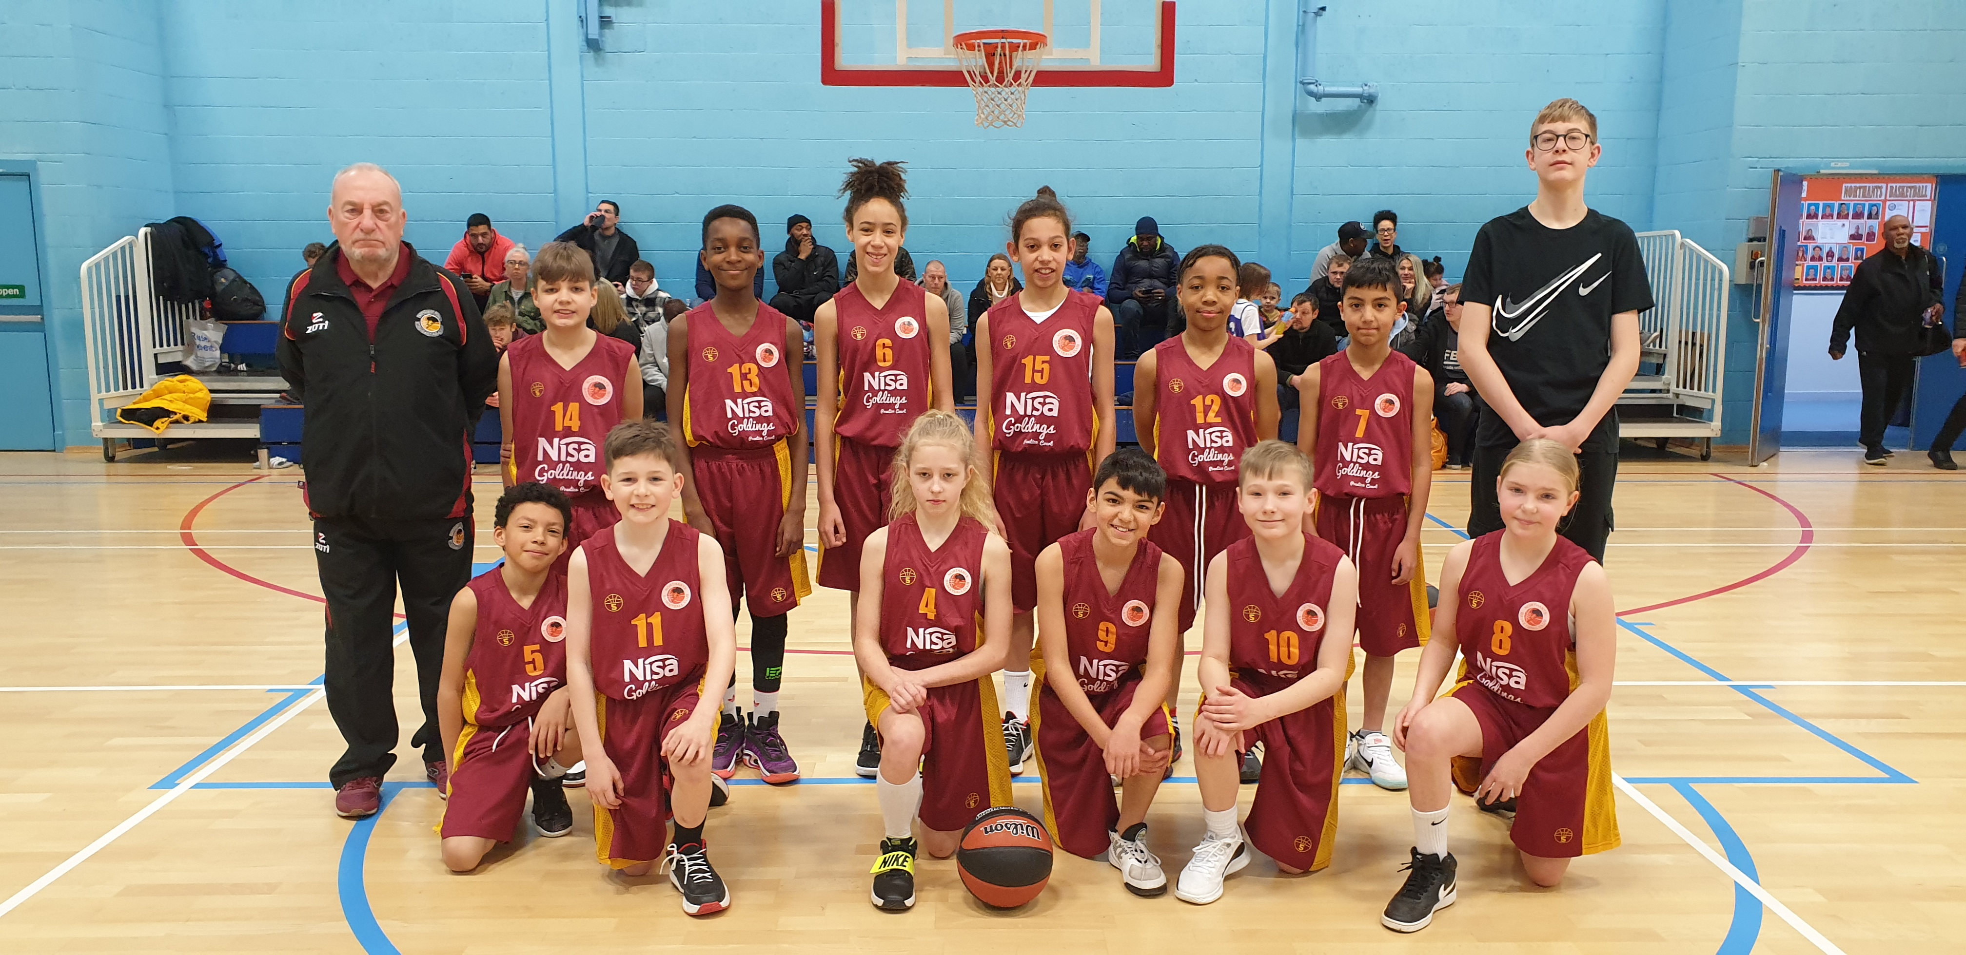

The Northants “Storm” Under 11 team before their YBL Play Off Tournament

THIS WEEKEND’S ACTION

Saturday 19th March
9-30 am to 10-30am “Budding “Ballers”
9-30am to 11-00am “Junior Ballers”
11-30am Under 12 Mixed Team versus Norfolk Inceni “Angels”
2-00pm Under 13 Boys versus Abingdon “Eagles”
4-00pm Junior Women versus City of Leeds

These games will be played at the Northants Basketball Centre at Northampton School for Girls
in Spinney Hill Road, Northampton NN3 6DG

Spectators are welcome and admission is FREE

Covid restrictions have now been eased but spectators are respectfully requested to respect other people’s health by abiding to social spacing and sanitising whenever possible

Sunday 20th March
Under 14 Girls travel to Daventry “Swifts”

For further information about this Press Release contact John Collins on +44 7801 533151

