NORTHANTS BASKETBALL CLUB

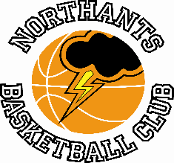

PRESS RELEASE

The Northants Club Junior Women say goodbye to Dina with a brace of wins.

‘Big four’ too much for gutsy Leeds

Junior Women’s (North Conference)
Northants “Lightning” 83 – 57 City of Leeds
A total of seventy five points from Dina Kosnikovska, Fernando Loberto, Gerda Vilcinskaite and Lucie Wilson-Gray steered the Northants Junior Women to a comfortable win over City of Leeds last Saturday.

Playing some of their best basketball of the season “Lightning” took the first quarter 27-12 with Loberto scoring 11 of those points. “Lightning” consolidated their advantage in the second quarter with Wilson-Gray and Vilcinskaite draining three-pointers and leading by 44 points to 23 at half time the game looked to be as good as over.

The two teams traded baskets in the third quarter, but “Lightning” were shaken by a 9-2 Leeds surge at the end of the quarter. “Lighting” was back to their best at the start of third quarter and a 17-4 run put the final result beyond doubt as the Northants girls cruised to a an 83-57 win, but all credit to the Leeds team who put up a gutsy performance and showed a great deal of good sportsmanship.

Vilcinskaite and Wilson-Gray led the “Lightning” scoring with 22 and 21 points respectively, Loberto contributing 17 and Kosnikovska 15.

Dina stars as “Lightning” beat “Spinners”

Northants “Lightning” 58 – 22 Lancashire “Spinners”

Back in September 2021 “Lightning” lost to “Spinners” by 14 points in the first game of the season with one of the “Spinners” players pouring in a massive 38 points. It was a very different Lancashire team that turned up at the Basketball Centre last Sunday having lost a number of players to illness and injury.

For their part “Lightning” looked jaded after their efforts against Leeds the previous evening and rarely established the offensive rhythm they had shown the previous day but excellent defence saw them establish a 28-6 half time lead the highlight of the half being a long range buzzer-beater from Dina Kosnikovska.

“Spinners” played with a lot more confidence in the third quarter which “Lightning” took 14-11 but it was business as usual in the fourth quarter as the Northants girls cruised to a 58-22 win which confirms a very creditable third place in the North Conference for Coach Emma Salisbury’s team.

In the low scoring game “Lightning’s” scoring was led by Kosnikovska playing her last game for the Club before moving on to university. Dina first played for the Club whilst at primary school and has made massive contributions to the club both as a player, a Young Leader and latterly as a table official. She has been a great credit to both herself and her family.

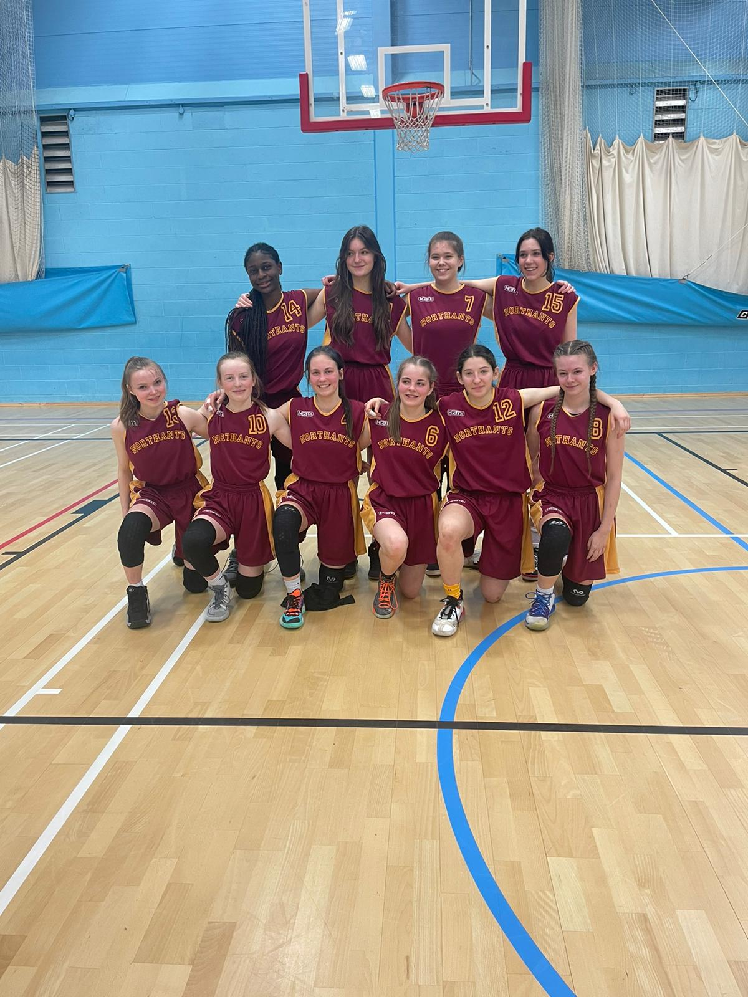

The Northants “Lightning” Junior Women after their win over Lancashire “Spinners”

Dina Kosnikovska is third on the left on the front row.

No game for Under 14 Girls in Daventry

Under 14 Girls Midlands Conference
Daventry “Swifts” 0 - 20 Northants “Lightning”

Despite their best efforts the new Daventry club were unable to find qualified and licenced officials for this game and the advice of East Midlands Basketball declined to play the fixture because the players would not have been insured.

By failing to comply with Basketball England regulations Daventry forfeited the game.

Below par Under 13 Boys see off “Eagles”

YBL Under 13 League South Conference
Northants “Thunder” 61 – 45 Abingdon “Eagles”

The Northants Under 13 Boys eventually saw off the challenge of second placed Abingdon “Eagles” despite missing an alarming 24 free throws. The “Thunder” victory came on the back of a dominant second quarter and a strong finish to the game, but Coach Steven Matthews’ team were below their best form for much of the games.

In the first game of the season “Thunder” beat “Eagles” by a single point and they were made aware that they were in for a tough game in the first quarter which “Eagles” took by 17 points 12 with “Thunder” guilty of missing a number of easy shots. An 18-zero surge in the second quarter was to prove conclusive for “Thunder” as they played their best defence of the game.

Leading 32-26 at half time “Thunder” were made to battle for points in the third quarter as the “Eagles” defence became more and more confident and more physical as “Thunder” continued to miss free throws. Trailing 38-45 “Eagles” were still very much in the contest going into the final quarter but led by Cameron Ivienagbor, “Thunder” opened the quarter in determined mood restricting their opponents to just one basket while scoring 10 themselves. There was no way back for “Eagles” as “Thunder” closed out the game and extend their unbeaten run to twelve games.

In the 16 point win, the “Thunder” scoring was led by Elijah Badero and Ivienagbor with 16 and 14 points respectively good support coming from Logan Tanner and Oliwier Andrzejczak scoring just five free throws from the 29 awarded is something the team will have to improve on.

Another blank day for Under 12’s

Under 12 Mixed League East Conference
Northants “Thunder” 20 - 0 Norfolk Inceni “Angels”

An outbreak of Covid in the Norfolk Club prevented them from fielding a team and can’t supply a date when they will be available to travel so have conceded the game.

The fixture was replaced by a Training Scrimmage Between the Northants Junior Men and Cadet Boys. The game ended in a win For the Cadet by 62 points to 53.

The Cadet scoring was led by Benas Maldutis with 21 points, good support coming from Jordan Gbanja, Jack Lemon and Rapolas Radavicius while for the Juniors Tom Greenfield scored 15 points and Fareed Isifu 11.

Massive final quarter not quite enough for “Thunder” Under 12’s

Under 12 Mixed League East Conference
Northants “Thunder” 52 – 60 Milton Keynes Basketball

Earlier in the season “Thunder” had lost to MK by 22 points so a victory by more than that margin was needed in this re-arranged game played last Monday at the Basketball Centre, if the Northants boys were to claim the East Conference title. In the event “Thunder” lost the game despite a spirited 14-zero charge in the last five minutes of the contest.

“Thunder” will look back on a poor third quarter which they lost 6-24 after trailing by just three points at half time and they never recovered from a 15-2 Milton Keynes’ surge at the start of that quarter. A time out by Coach Mark Spatcher steadied the ship but the twenty point deficit going into the final ten minutes of play was to prove too much.

Going into the last five minutes of the game MK led 54-34 and this lead was increased to 23 when Sochan-Lipiecke drained a three-pointer. The vociferous MK supporters settled down in the expectation of an easy cruise to victory, but “Thunder” had other ideas and a combination of determined pressure defence which forced numerous turn overs and some aggressive drives to basket saw the home team mount a determined challenge. Now it was the voices of the “Thunder” supporters that were in the ascendency as basket by basket the lead was reduced. In the end “Thunder” ran out of time but their efforts had kept Milton Keynes scoreless for over five minutes while scoring 14 points themselves.

So, victory and the Conference title for MK but the real winner was basketball with the game a great credit to the players and coaches of both teams.

In the eight point defeat Anton Kelly and Jowell Stiete- French led the “Thunder scoring with excellent support coming from Luca Garrett and Osagie Efosa.

THIS WEEKEND’S ACTION

Saturday 26th March
9-30 am to 10-30am “Budding “Ballers”
9-30am to 11-00am “Junior Ballers”
10-30am to 11-00am Presentation of Awards for “Ballers” Programme

12-00pm Under 11 Girls versus Milton Keynes
Under 13 Boys versus Bournville “Bears”
2-00pm Under 15 Boys versus Leicester “Riders”

These games will be played at the Northants Basketball Centre at Northampton School for Girls
in Spinney Hill Road, Northampton NN3 6DG

Spectators are welcome and admission is FREE

Covid restrictions have now been eased but spectators are respectfully requested to respect other people’s health by abiding to social spacing and sanitising whenever possible

11-00am Under 14 Boys ‘A’ Team versus Northamptonshire “Titans”
@ Northampton School for Boys

Sunday 27th March
Under 14 Boys ‘A’ Team travel to West Suffolk “Wolves”

For further information about this Press Release contact John Collins on +44 7801 533151

