NORTHANTS BASKETBALL CLUB

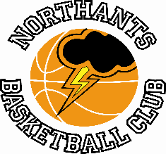

PRESS RELEASE

The final weekend of the National League season saw the Under 14 Boys go one and one while there were YBL wins for both the Under 13 and 15 Boys while the Under 11 Girls created history.

Revenge is sweet for Under 15 Boys

YBL Under 15 Boys Primis League
Northants “Thunder” 59 – 52 Leicester “Riders”

Just a fortnight ago “Thunder” lost to “Riders” by 14 points but there was a positive feeling in the team that they could reverse the result and they did just that last Saturday thanks to some obdurate defence and refusal to give in even when things were going against them.

After a poor start “Thunder” were able to re-group but still trailed 16-15 after the first quarter. They battled their way into a 26-19 lead only to be hit by a 16-zero “Riders” charge which saw them trailing 28-35 at half time.

Coach Brad Hughes had stern word for his charges at half time and his team responded well and some inspired defence in the third quarter restricted “Riders” to just five points while six “Thunder” players contributed 13 points to give “Thunder” a 41-40 advantage going into the last ten minutes of play. “Thunder” was able to maintain their defensive intensity in the final quarter and thanks to three-pointers from Jake Muxlow and Angus Slater took the quarter 18-12 and the game by 59 points to 52.

In the seven points win the “Thunder” scoring was led by Thomas Bates with 21 points and he was well supported by Muxlow and Slater with 15 and 11 points respectively, but this was a victory for the whole team with every player playing important roles particularly on defence

Under 14 Boys finish on a high

Under 14 Boys East Conference
Northamptonshire “Titans” 67 – 42 Northants “Thunder”

The Northants Under 14 Boys opened their busy weekend with a short trip to Northampton School for Boys to take on “Titans” a team that had beaten them by 65 points earlier in the season.

“Thunder” made a good start to the game but then ‘lost their way and found themselves trailing 6-18 after the first quarter and this deficit extended to 19-37 by half time. By but by this time “Thunder” were beginning to show more appetite for the contest and they won the third quarter 11-8 displaying a great deal of determination on defence.

By now Conference title seeking “Titans” lead had been cut to fifteen points and they ‘upped’ their efforts with a full court pressing defence in the final quarter to re-establish their supremacy. They eventually won the quarter 22-12 to take the game by 67 points to 42. “Titans” total of 67 points was their lowest of the season

No “Thunder” player was able to score in double figures but Logan Ormshaw and Alex Bott scored eight points each while Kane Young dished out seven assists.

West Suffolk “Wolves” 52 – 77 Northants “Thunder”

Twenty four hours later well, 23 with the clocks going forward, a depleted “Thunder” were ‘on the road’ to Bury St Edmunds for their last game of the season against bottom of the table West Suffolk “Wolves” who had a new look with a new coach and several new players.

Despite tired legs “Thunder” were able to secure the win with Kamil Jazwinski and Henry Branderick dominating the battle of the boards pulling down over 30 rebounds between them. Jazwinski also scored 20 points and Branderick 10 to complete double-doubles; James Kennet-Maughan contributed 17 points while Kane Young had an impressive 14 assists. After getting involved in a bit of a ‘dog fight’ in the first half “Thunder” were able to impose their class on the game in the second with some excellent ball movement.

This game represented the last for Coach David Young and the Club would like to thank David who also coached the ‘B’ team, for his enthusiasm, dedication, and commitment.

Cometh the hour, cometh Oliwier

Under 13 Boys maintain their unbeaten record…..just

YBL Under 13 League South Conference
Northants “Thunder” 93 – 83 Bournville “Bears”
(77 - 77)
With less than a minute of this compelling game remaining, Logan Tanner scored to tie the scores at 77 all and take the contest into overtime. In the first four minutes of the extra period Oliwier Andrzejczak took proceedings into his own hands and reeled off ten personal points to take “Thunder” to a win which, when they trailed by 13 points early in the third quarter had looked very unlikely.

In the first quarter of the game third placed “Bears” gave notice of their ability as they eased out to an 18-17 lead with ten of “Thunder’s” points coming from Logan Tanner. “Bears” maintained their ascendency in the second quarter which they won 20-14 to establish a 38-31 half time lead.

The Birmingham team started the third quarter with a 6-zero charge to open up a 13 point lead and it was only then that Coach Steven Matthew’s team began to play to their full potential with eight players contributing to a 24-4 charge which gave “Thunder” a 63-55 lead going into the final ten minutes of play.

That lead was extended to ten points early in the fourth but then “Bears” mounted a stunning 14-zero run to re-take the lead and “Thunder” knew they were in for a tough final five minutes. “Thunder” were relying heavily on Tanner for their points, and it was he who score the equalising basket and ‘opened the door for the Andrzejczak heroics.

In the ten point win which extends the team’s winning run to thirteen, ten “Thunder” players contributed to the scoring led by Tanner with a 32 point haul while Andrzejczak had 20 points. This weekend “Thunder” face another big challenge when they travel to Frankley “Falcons” a team that ran them close earlier in the season.

Under 11 Girls create a little bit of history

Under 11 Girls Challenge game
Northants “Lightning” 19 – 58 Milton Keynes Basketball

On Saturday at the Basketball Centre a little piece of history was made when the Northants Basketball Club fielded an Under 11 Girls team. The nine girls representing the Club took on Milton Keynes Basketball and lost to a team with considerably more playing experience than the “Lightning” girls.

The Northants girls battled to the end no one more than Urte Maldutyte and Coach Karen Goodrich expressed the view that her team had all learned a great deal from the experience.

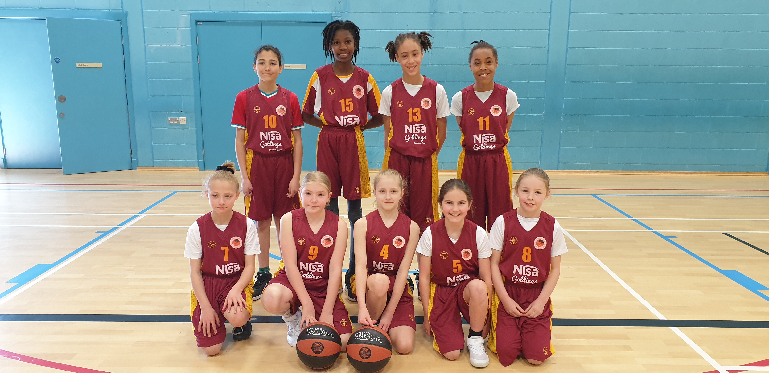

The history making “Lightning” Under 11 Girls team

“Ballers” Presentations

Last Saturday over 30 boys and girls received their attendance certificates for the 2021 / ’22 Ballers Programme. The Coaches and Young Leaders also made awards to players who had done particularly well.

Awards: “Junior Ballers” Most Valuable Player Jude
Most Improved Player Kian
Hardest Worker Mila
Commitment Akev
Bravery Xavier

“Budding Ballers” Most Valuable Players Joe and Olivia
Most Improved Player Luca

Players Player Charlie

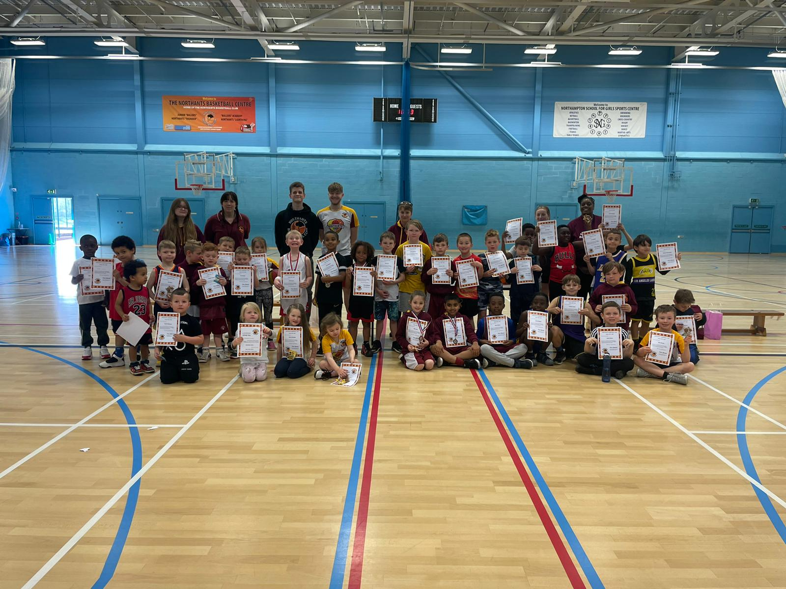

The “Ballers” and “Budding Ballers” with their certificates

THIS WEEKEND’S ACTION

Saturday 2nd April
Under 16 Boys travel to Cheshire “Phoenix I” (Promotion Play Off game)

Under 13 Boys travel to Frankley “Falcons”

For further information about this Press Release contact John Collins on +44 7801 533151

