NORTHANTS BASKETBALL CLUB

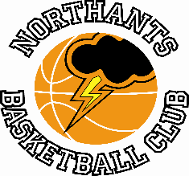

PRESS RELEASE

A quiet weekend for the Northants Basketball Club but the “Thunder” Under 13 Boys did extend their unbeaten run to fourteen,

No stopping the “Thunder” Under 13 Boys as they extend their unbeaten record to fourteen.

YBL Under 13 League South Conference
Frankley “Falcons” 46 – 75 Northants “Thunder”

The “Thunder” Under 13 Boys travelled to south-west Birmingham last Saturday to take on Frankley “Falcons” a team that had caused them a great deal of problems when the two teams had met at the Basketball Centre earlier in the season. In the event “Thunder” completed the double with a comfortable victory thanks to a determined defensive display and an offensive performance which saw eight players contributing to the final total.

“Thunder” found scoring difficult in the first quarter with only Elijah Badero and Logan Tanner finding the basket, but an amazing defensive effort restricted “Falcons to a miserly seven points, “Thunder” scoring 10.

The “Thunder” scoring machine clicked into gear in the second quarter and the visitors took control of the game taking the quarter 21-12 to lead 31-19 at half time.

The team has been working hard on their defence over the past two weeks and this was shown once again in the third quarter with the home side limited to just 11 points with Athandios “TK” Kiaifas setting an excellent example of hustle and determination. Leading 37-22 a 12-2 surge including two three-pointers from Cameron Iviengbor gave “Thunder” complete control of the game as they went into the final ten minutes of play leading by 55 points to 30.

The final quarter saw Wilson Carr and Oliwier Andrzejczak the hero from the previous week’s game take the offensive limelight as “Thunder” added a further 20 points although they did allow “Falcons to score 16 but the result was never in doubt as “Thunder” maintained their perfect record.

In the 29 point win Andrzejczak, Badero, Carr, Iviengbor and Tanner all scored in double figures but it was the team’s defensive effort that had been the key to defeating a physically aggressive “Falcons” team,

Under 16 Boys are given a Play Off bye

Under 16 Boys Promotion Play Offs
Cheshire “Phoenix” 0 – 20 Northants “Thunder”

The Cheshire “Phoenix” team has been having personnel problems all season and were unable to field a team for this Promotion Play Off game last Saturday so conceded the game to “Thunder”.

In the next round the Northants team will face Merseyside “Mavericks” who defeated Junior Sheffield “Sharks” by seven points. The game is scheduled for this coming weekend with “Thunder” having home court advantage, but Northampton School for Girls is closed for the Easter holidays, so the two clubs are looking for an alternative date.

Good news for the “Thunder” Under 12 Mixed team

The “Thunder” Under 12 Mixed team finished second to Milton Keynes in the East Conference and were disappointed to discover that Basketball England would not be running Play Offs.

Last week the Club was informed that the London Elite club was willing to run ‘unofficial’ Play Offs. All the top teams in the country have agreed to participate and “Thunder” will play London Baltic Stars Under 11’s on Saturday 23rd April at the Basketball Centre,

.

Casual Sessions Presentations

This season the Northants Basketball Club has been running a series of Casual Sessions for boys and girls new to the sport or not quite good enough yet, for one of the competitive teams. The sessions supervised by coaches Ellie Birch and Darjius Maldutis assisted by his son Benas have been a great success attracting almost 50 Under 13 boys and girls this added to over 40 Under 11’s.

Last Thursday saw the last sessions of the programme and at the end coaches Birch and Maldutis presented the players with attendance certificates and then made their awards.

Awards:
Boys Most Valuable Player Hayden

Girls Most Valuable Player Emily

Boys Most Improved Player Taran

Girls Most Improved Player Jordanna

Boys Leadership Award Kostas

Girls Leadership Award Cleo

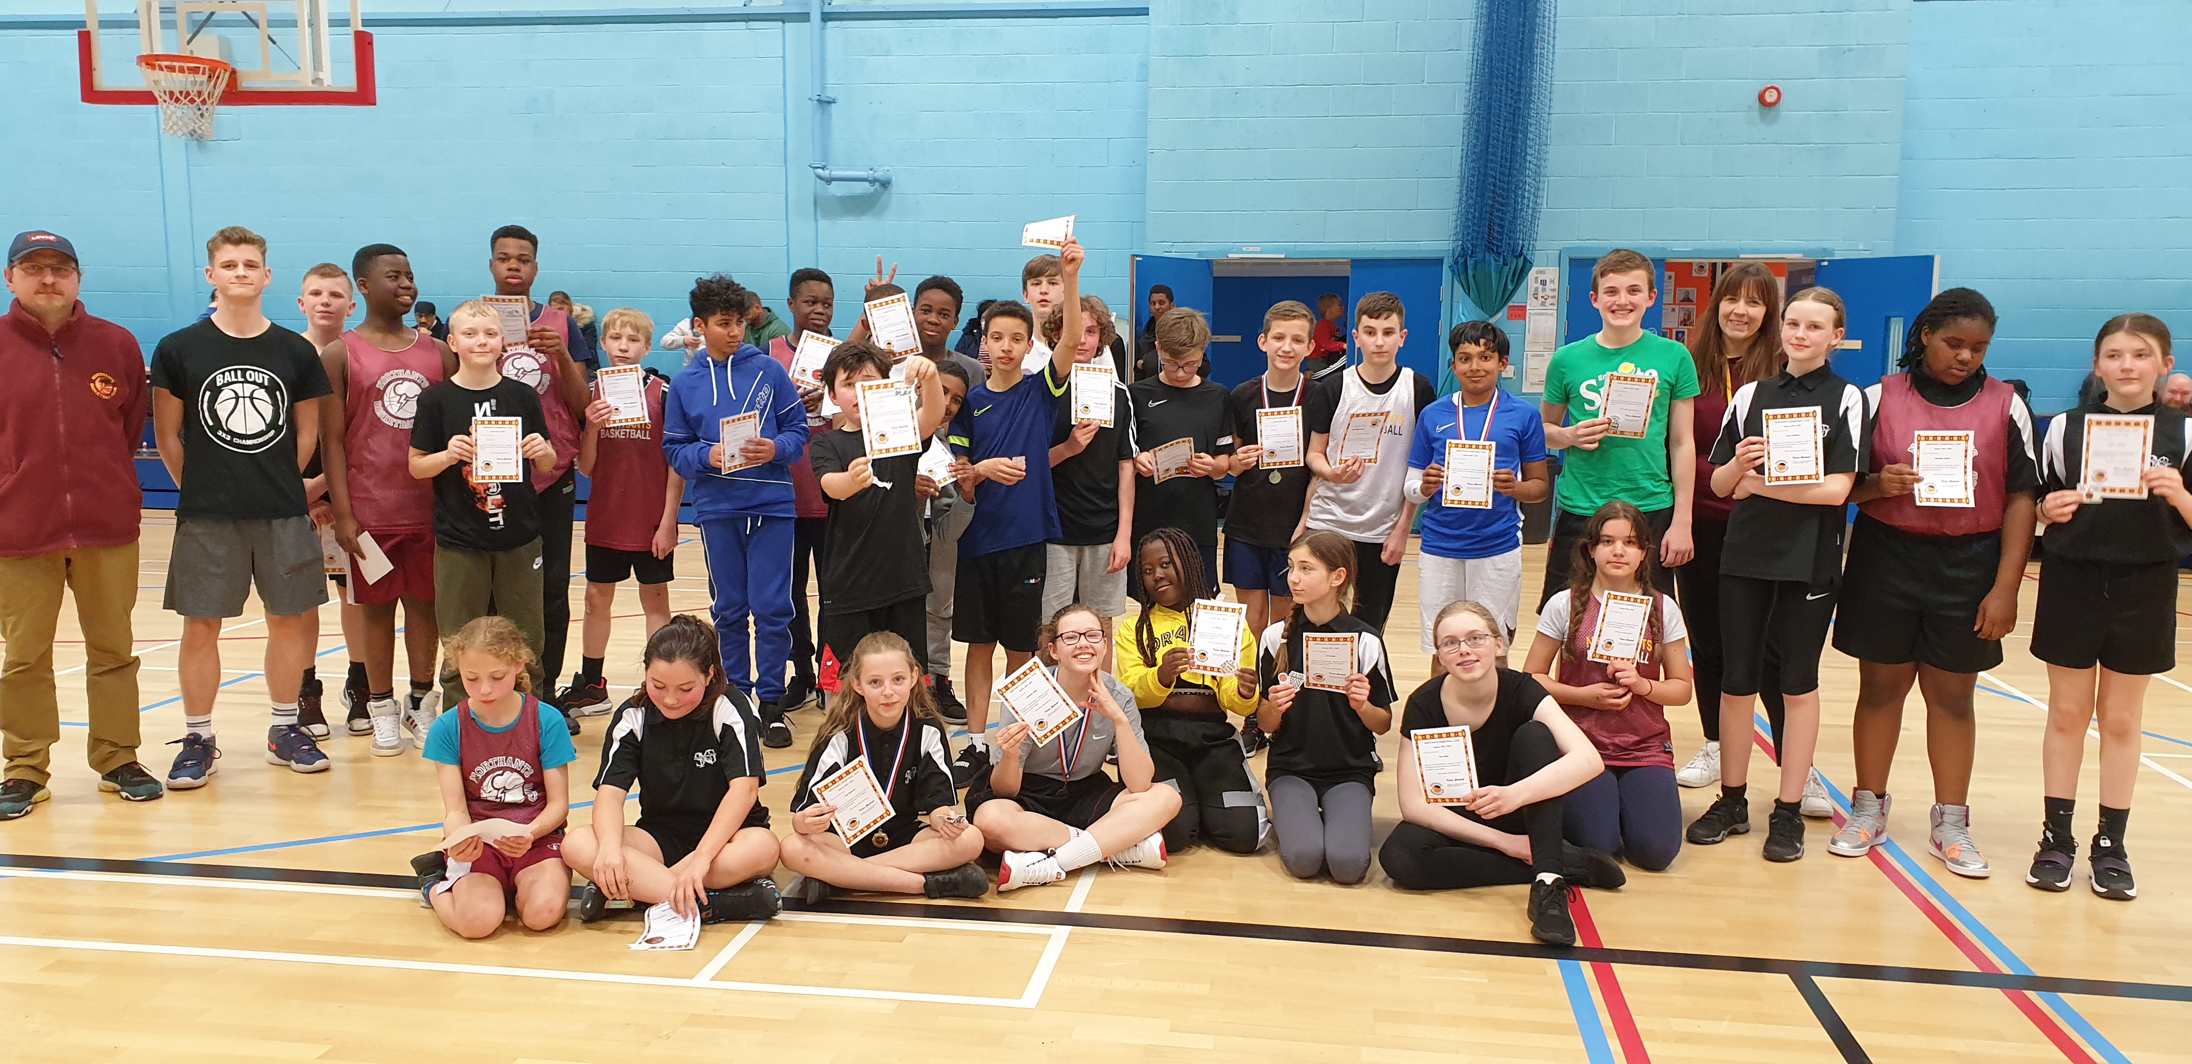

The Under 13 Casual Sessions players with their attendance certificates

THIS WEEKEND’S ACTION

There are no practices or games at the Basketball Centre this week, but a series of Day Camps will be held
during the course of this week

For further information about this Press Release contact John Collins on +44 7801 533151

