NORTHANTS BASKETBALL CLUB

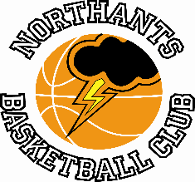

PRESS RELEASE

No competitive action for the Northants Basketball Club last weekend but news of the Pre-Easter Camps the Presentation Evening and the Play Offs.

Pre-Easter Camps a big success

Following on from last year’s successful Camps the Northants Basketball Club repeated the exercise over the past to weeks and unlike last year’s Covid affected events this year’s camps were held indoors.

The Camps were supervised by Brad Hughes while Ellie Birch looked after the younger players and Dawn Greenfield carried out the all-important administrative duties. Coaches Birch and Hughes were assisted by Young Leaders, Dani Jokulis, Alannah Major, Benas Maldutis, and Lucie Wilson-Gray, with the camps offering players the opportunity to hone their skills as well as enjoy fun activities and play games.

The Camps were held over four days, and they proved to be very successful with well over 90 boys and girls attending.

Club President, John Collins commented, “For many of our players the regular season has finished so the Camps were a great opportunity for them to continue playing before our Post Season Programme begins.”

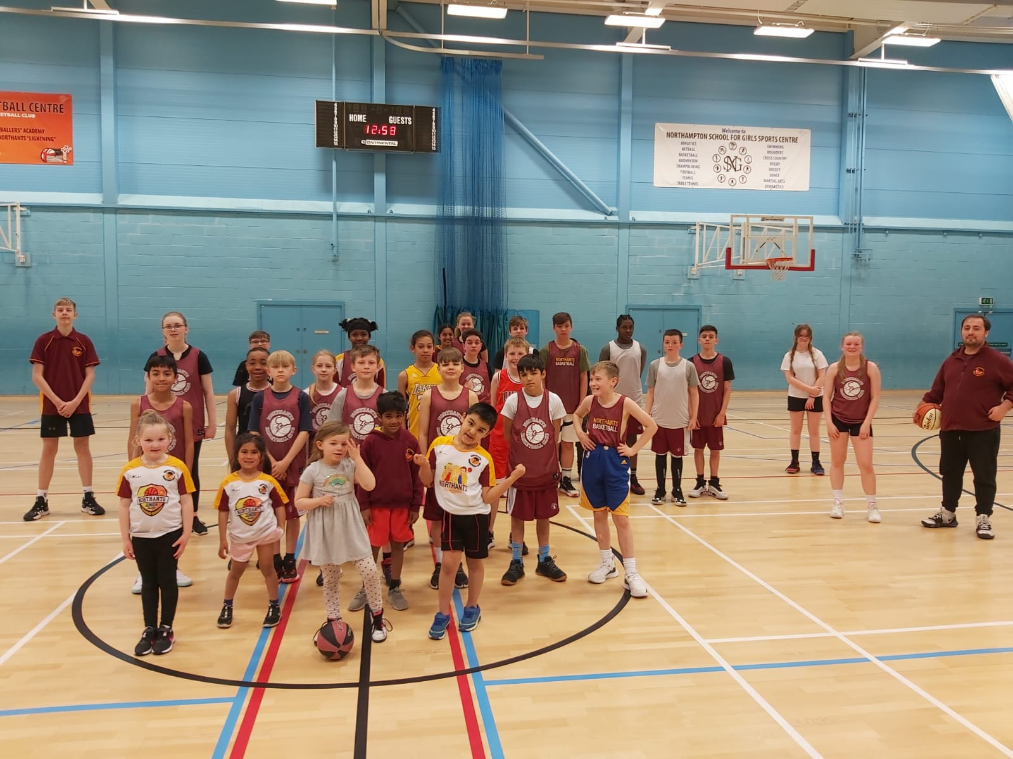

“Let’s go camping”

One of the Pre-Easter Camp groups with Coach Brad Hughes and Young Leader Dani Jokulis

Play Off opponents confirmed

The opponents for the “Thunder” Under 12 Mixed team and Under 16 Boys have now been confirmed. The Under 12’s will play London Baltic Under 11’s in their unofficial Play Off while the Under 16 Boys will take on Merseyside “Mavericks” following their 1st Round Bye in the Promotion Play Offs.

Both games will be played at the Basketball Centre at Northampton School for Boys on Saturday 23rd April.

Change of venue for Presentation Evening

Such has been the demand for tickets for the club’s End of Season Presentation Evening that a late change of date and venue has become necessary. The event will now be held in the Rodber Room at cinch stadium @ Franklin’s Gardens on the evening of Wednesday 20th April.

Over 350 players, parents and friends have already signed up for the event but there are still a few tickets remaining and anyone interested in making a late booking can do so through the club’s email:
northantsbasketballclub@hotmail.co.uk

The event, the first for three years will comprise a Review of the Season, Coaches and Player’s Awards and an
on-going Team Quiz

For further information about this Press Release contact John Collins on +44 7801 533151

