NORTHANTS BASKETBALL CLUB

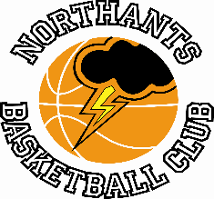

PRESS RELEASE

Play Off disappointment for below par Cadets

Under 16 Boys Promotion Play Off 2nd Round
Northants “Thunder” 52 – 64 Merseyside “Mavericks”

In front of a raucous crowd Merseyside “Mavericks” took this Under 16 Boys Promotion game by 12 points to move on to the semi-finals.

The Merseyside arrived with a bus load of supporters, a mascot in full costume and cheerleaders and this group combined with a hoard of “Thunder” supporters provided an amazing atmosphere at the Basketball Centre last Saturday.

Both teams looked nervous throughout the first quarter and “Thunder” looked like what they were; a team that hadn’t played a competitive game for three weeks. Despite this they edged the first quarter 12-11 but this lead was wiped out early in the second quarter and “Thunder” were left to play ‘catch up’ for the rest of the game.

“Thunder” were opting to play a controlled half-court game, but their offence lacked fluidity and they could manage just nine points in the second quarter and to find themselves trailing 21-31 at half time.

An 11-2 surge inspired by the hustle of Jack Lemon early in the third quarter brought “Thunder” to within a point at 32-33 but then they were then hit by a 17-2 “Mavericks” charge from which they never recovered.

“Thunder” won the final quarter 15-14 but despite their best efforts they never seriously looked like overcoming the deficit as “Mavericks” held on for the 12-point victory to the delight of their travelling fans.

In the disappointing loss Benas Maldutis top scored for “Thunder” with 14 points but Lemon and Rapolas Radavicius were the only other ”Thunder” players to score in double figures and the team were left to reflect on a game they might or even should have won. In the event they lost but they can be very proud of winning the East Midlands Conference title

Brave Under 12’s go down to Baltic “Stars”

Under 12 Unofficial Play Offs
Northants “Thunder” 63 – 74 Baltic “Stars” Under 11’s

A 37 points haul from Luca Garrett and Anton Kelly couldn’t prevent the Northants “Thunder” Under 12 Mixed team going down to a talented under-aged Baltic Stars team. “Thunder” will look back on two periods of play when they were heavily outscored the first late in the opening quarter when “Stars” poured in 12 unanswered points and the second in the third quarter when “Thunder” were outscored 16-6. On the first occasion the Northants boys battled back gamely but the second set back proved to be too much for them to overcome despite their very best efforts.

“Stars” took the first quarter 22-9, but “Thunder” closed the gap in the second quarter which they won 18-12. Leading 34-27 at half time “Stars” pulled out to a 62-40 lead by the end of the third and the Londoners held on for the 11 point win despite a superb final quarter effort from the “Thunder” players which saw them win the quarter 23-12.

In addition to Garrett and Kelly, “Thunder” got important contributions from Osagie Efosa, Jerome Maroodza and Joelle Stiete-French, but Coach Mark Spatcher can’t have been happy with his team missing an alarming 32 free throws.

So, the season ends for the team who claimed second place in the East Conference and only lost three games all season.

Play Off setback for “Thunder” Under 15 Boys

YBL Primis League
Northants “Thunder” 76 – 80 Warwickshire “Hawks”

Hopes of a ‘seeded’ place in the Play Offs for the “Thunder” Under 15 Boys suffered a major setback after losing to a spirited Warwickshire “Hawks” team. The defeat was largely down to an appalling third quarter when “Thunder” were outscored 25-13 during which time they missed countless close to the basket shots. They were also hampered by injuries to leading scorer Thomas Bates and Danielas Jokulis.

At half time “Thunder” led by 45 points to 39 thanks to 18 points from Bates but they were unable to open up a substantial gap against a determined “Hawks” team. During the third quarter not only were they unable to convert easy scoring opportunities they also struggled to contain the driving play of “Hawks” Goldie.

Trailing 58-64 going into the last ten minutes of play, “Thunder” needed someone to ‘step up’ and that player proved to be Logan Ormshaw who showed the more senior players in the team how to play with passion and determination. Not only did the rookie score 12 points in the final quarter he also restricted Goldie to a single basket. “Thunder” did get the deficit down to two points at 70-72 at one stage but despite missing a number of free throws “Hawks” held on for a deserved four points win.

In the disappointing defeat the “Thunder” scoring was led by Bates and Ormshaw with 22 and 12 points respectively while Jake Muxlow contributed ten.

“Storm” Gold win Under 11 Invitational Tournament

Teams from Northamptonshire “Titans” and Nottingham based East Leake “Globetrotters” joined two teams from the Northants Club for this latest Under 11 Tournament. The two “Storm” teams who were coached by Young Leaders Dani Jokulis and Thomas Bates won both their games and in the game for first place “Storm” Maroon squeezed home by a single basket while in the 3rd and 4th placed decider East Leake “Globetrotters” defeated “Titans” thanks to a ‘buzzer’ beater.

Storm Maroon 36-14 Northamptonshire Titans
Storm Gold 28-10 East Leake Globetrotters
Storm Maroon 43-12 East Leake Globetrotters
Storm Gold 26-8 Northamptonshire Titans
Northamptonshire Titans 18-20 East Leake Globetrotters
Storm Maroon 26-28 Storm Gold

1st Storm Gold 2nd Storm Maroon
3rd East Leake 4th Northamptonshire Titans

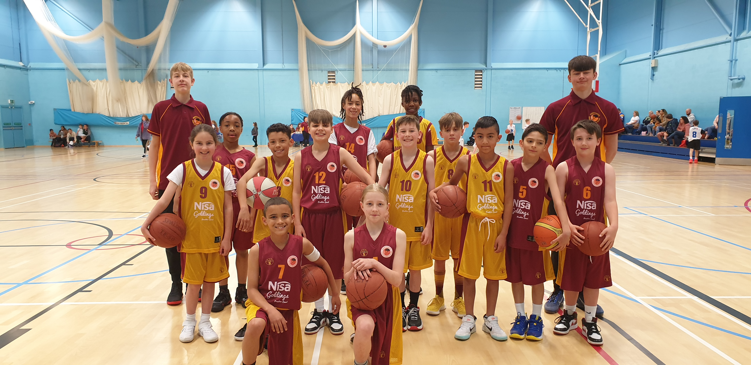

The Northants “Storm” Gold and Maroon teams with coaches Dani Jokulis and Tom Bates
Great turnout for Presentation Evening

Three hundred and sixty players with their families gathered in the Rodber Room at the cinch stadium @ Franklins Gardens last Wednesday for the Club’s End of Season Presentation Evening for the club’s ten competitive teams. Team coaches gave an overview of their team’s performances and awards were made to players and adult volunteers.

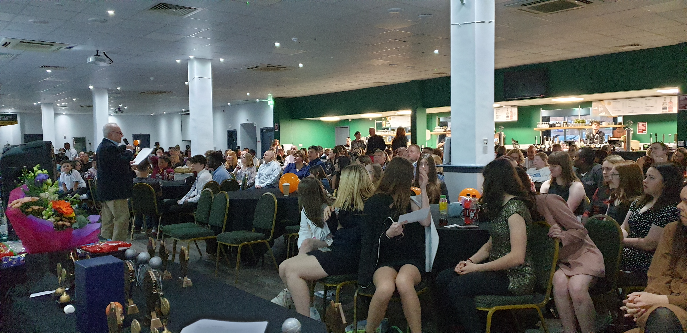

Part of the audience at last week’s Presentation Evening

The award winners were:
Under 11 “Storm” Most Valuable Player – Kyjah Adams Players Player – Max Abraham

Under 12 Mixed Most Valuable Player – Luca Garrett Players Player – Anton Kelly

Under 13 Boys Most Valuable Player – Logan Tanner Players Player – Cameron Iviengbor

Under 14 Girls Most Valuable Player – Jennifer Oamen Players Player – Lauren Eighteen

Under 14 Boys ‘B’ Most Valuable Player – Samuel Ortenga Players Player – Brody Garrod

Under 14 Boys ‘A’ Most Improved Player – Henry Brandrick Players Player – Logan Ormshaw

Under 15 Boys Most Valuable Player – Jake Muxloe Players Player – Thomas Bates

Cadet Boys Most Valuable Player – Brad Yeomans Players Player – Benas Maldutis

Junior Women Most Valuable Player – Dina Kosnikovska Players Player – Lucie Wilson-Gray

Junior Men Most Valuable Player – Benas Maldutis Players Player – Dylan Dominici

The following players who are leaving the Club or left the Club over the Covid period were presented with Long Service Awards.
The recipients were: Poppy Barnett, Ethan Clarke, Dina Kosnikovska, Lucy Needham, Niamh Saysell and
Adam Shannon-Brooks

Special Long Service Award Coach Emma Salisbury

The Penny Westwood Fair Play Award Coach Brad Hughes

Administrator’s Award Lucie Wilson-Gray

President’s Award Emma Moore
For further information about this Press Release contact John Collins on +44 7801 533151

