NORTHANTS BASKETBALL CLUB

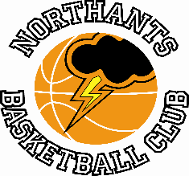

PRESS RELEASE

Under 13 Boys go marching on to the Play Offs

Youth Basketball League Under 13 Boys League
(South Conference)
Yardley “Defenders” 13 – 102 Northants “Thunder”

The organisers of the Youth Basketball League had intended to run a Primis (Premier) Division for Under 13 Boys this season but didn’t get enough entries so opted for the conventional mixed league. The need for an elite division was clearly shown when Northants “Thunder” visited mid-table Yardley defenders and won by the preverbal ‘country mile’.

The win confirms “Thunder’s” end of season Play Off spot and guarantees them a seeded place. The Play Offs will be played in June in Hereford.

Against Birmingham based Yardley, “Thunder” topped twenty points in all four quarters while their resolute defence restricted the game “Defenders” to less than ten points in all four sessions.

Eight “Thunder” players contributed to the final total led by an irrepressible Cameron Iviengbor with a
30-point tally while Wilson Carr, Logan Tanner and Olivier Andrejczako all scoring in double figures the latter finishing with a game closing 12 point flourish.

This weekend “Thunder” travel to mid table Redditch safe in the knowledge that in the 1st Round of the Play Offs they will face the second placed team in the North Conference which looks likely to be Tamworth “Tigers”

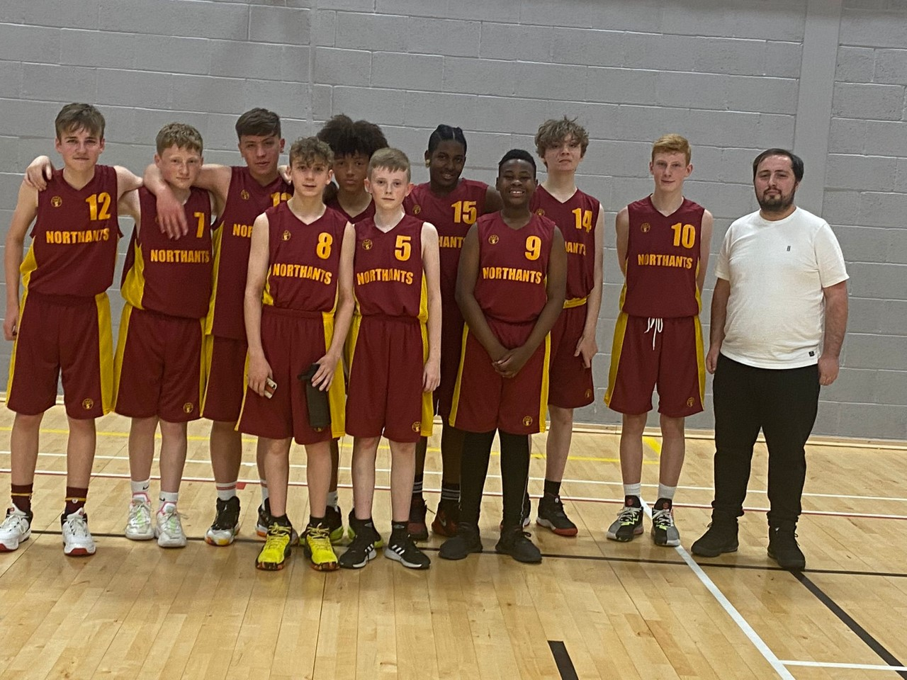

The Northants “Thunder” Under 13 team with stand in coach Bard Hughes after securing
the YBL South Conference title

THIS WEEKEND’S ACTION

Saturday 7th May
9-30am Budding “Ballers”
10-30am Junior “Ballers”
11-30am “Lightning” Girls Development Group

Under 13 Boys travel to Redditch Basketball

Sunday 8th May
9-30am “Storm” Boys Under 13 Development Group

For further information about this Press Release contact John Collins on +44 7801 533151

