NORTHANTS BASKETBALL CLUB

PRESS RELEASE

County pair get Great Britain call ups

Two county ‘ballers will compete in the XIth FIMBA Maxi Basket European Championships to be staged in the Andalusian province of Malaga from 24th June until 3rd July. This event was due to be held last summer but was cancelled because of Covid.

The two are Max Curle who has been selected for the GB Over 35 Men’s team and Anita Curtis who has been chosen as head coach of the Over 50’s Women’s team,

Max, who hails from Daventry where he attended Danetre School played for various age group teams of the Northants Club before moving to London where he studied at London Metropolitan University. While in the capital he played national league basketball with a number of London based clubs before moving back to the county in 2019. Since then, he has played local league basketball with Wellingborough Phoenix and more recently national league basketball with Coventry “Flames”.

A personal trainer Max spends some of his weekends in Frankfurt, Germany where his two young sons live, and he has played with the Makkabi Frankfurt team in a regional league. He put his name forward for the G.B. team back in 2021 and has attended numerous practices and weekend camps and heard he had been selected for Malaga early last month. He is the only player from the original group of players to gain selection after a great deal of recruitment by the team coach Liam Jefferson.

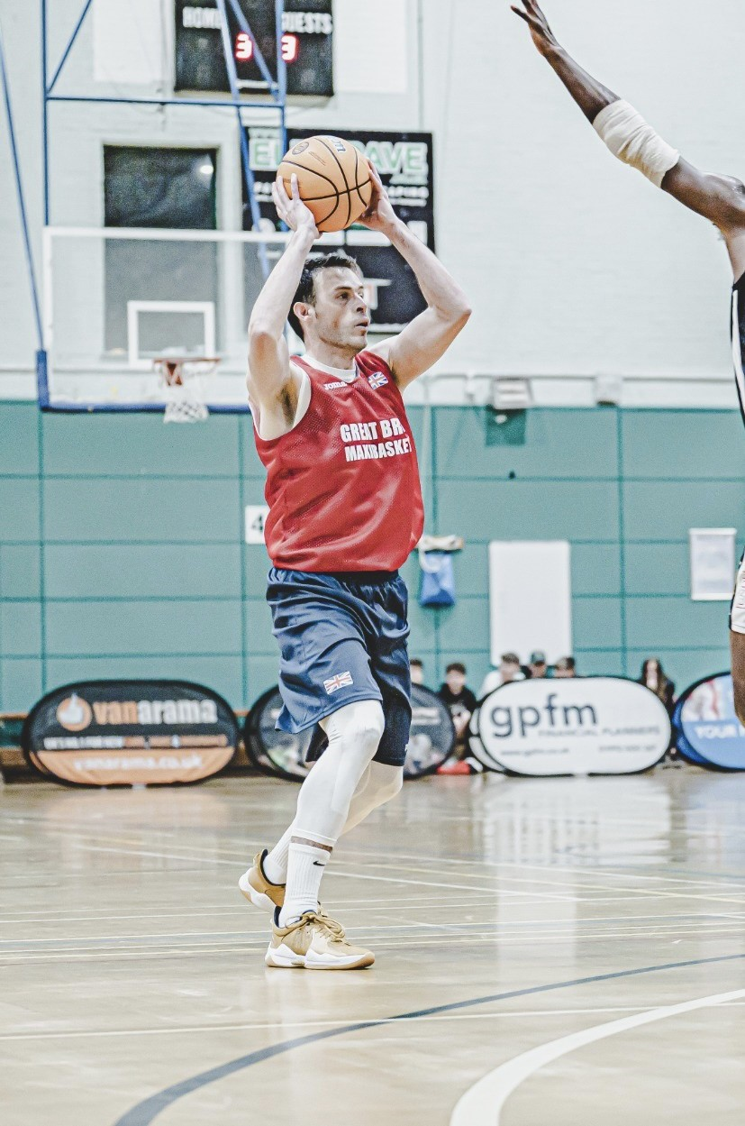

Max Curle playing for the G.B. Over 35 team in a recent training game
Anita Curtis was brought up in Royston and enjoyed an outstanding national league playing career with both Corvus Cornix and Avon Cosmetics picking up fourteen national titles with the latter club. She also played with great distinction for both England and Great Britain taking part in numerous Four Countries and European Championships as well as three Olympic Qualifying tournaments. As a coach she has experience at both local and national league levels and this experience will be invaluable to her Over 50’s team many of whom Anita played against during her playing career.

Before travelling to Spain, the team will have a number of weekend preparation camps in preparation for what is likely to be an extremely tough competition in Malaga.

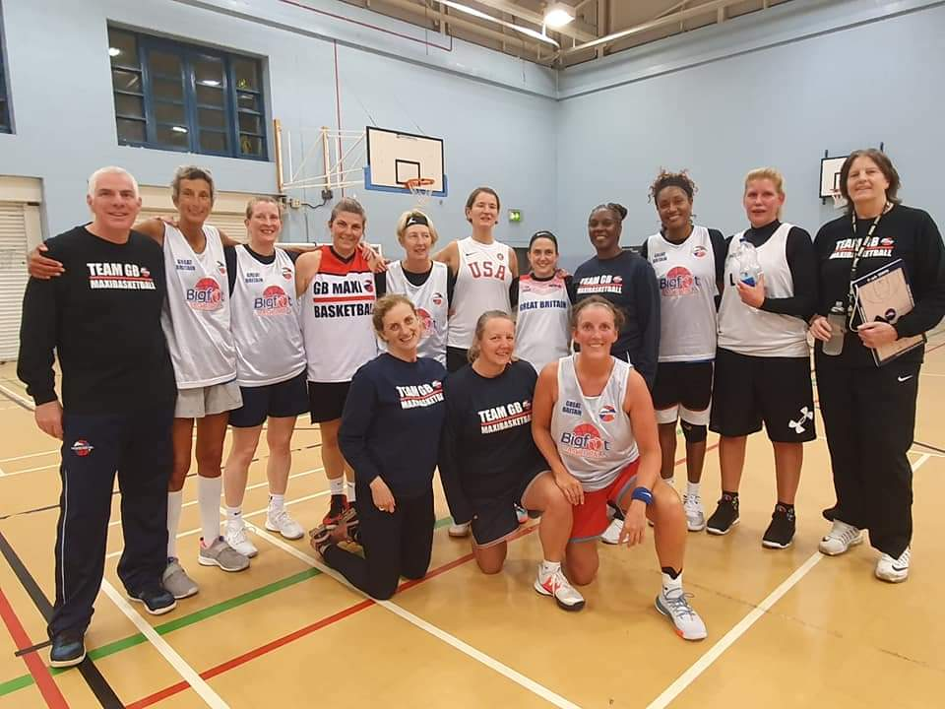

Coach Anita Curtis (far right) with the Great Britain Over 50’s team at a recent Training Camp

The Great Britain Maxi basketball Programme was adopted as part of Basketball England’s Talent Pathway and receives a little funding from the national teams’ budget, but all the players, coaches and team managers are paying a substantial amount of money out of their own pockets to play in the tournaments. Anita and Max would really appreciate any financial support they could obtain, and this would be an ideal opportunity for a local business to sponsor an outstanding athlete and a vastly experienced coach to represent Great Britain.

“Thunder” Under 13 Boys are PERFECT

Youth Basketball League Under 13 Boys League
Redditch “Rookies” 43 – 84 Northants “Thunder”

With this win the Northants “Thunder” Under 13 Boys team made it fourteen wins from fourteen starts to complete a perfect Conference season. The team will now prepare for the end of season Play Offs in Hereford where they will face North Conference runners-up Tamworth “Tigers”.

Against Redditch, “Thunder” turned in a thoroughly professional performance combining aggressive defence with a mixture of fast break basketball and half court offences which saw ten players contributing to the final total led by Cameron Ivienagbor with 26 points. Oliwier Andrzejcza and Wilson Carr also scored in double figures but much to the delight of team coach Steven Matthews this was a real team effort controlled by the immaculate ball-handling skills of Alfie Serbyn.

“Thunder” dominated all four quarters of the game and during the first two quarters restricted “Rookies” to just 16 points while pouring in 41 themselves. With the game as good as over as a contest Coach Matthews was able to give all his players ample court time and they didn’t disappoint especially Elijah Bandero who announced his arrival on court with four spectacular ‘blocks’ which left the Arrow Vale Sports Centre crowd in awe.
The team now has several weeks preparation time in readiness for the Play Offs.

THIS WEEKEND’S ACTION

Saturday 7th May
9-30am Budding “Ballers”
10-30am Junior “Ballers”
11-30am “Lightning” Girls Development Group

Sunday 8th May
9-30am “Storm” Boys Under 13 Development Group

“Storm” Under 11 team travel to Birmingham for their final Runners Up CVL Tournament

For further information about this Press Release contact John Collins on +44 7801 533151

