NORTHANTS BASKETBALL CLUB

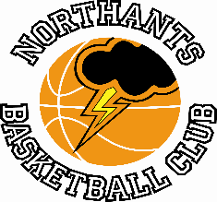

PRESS RELEASE

Double disappointment in Youth Basketball League Play Off Semi Finals

The Northants “Thunder” Under 13 and 15 Boys teams travelled to Hereford last Sunday for the YBL Play Off semi-finals and both made the long trip home having lost to West Bromwich Basketball and Leicester “Riders” respectively.

YBL Under 13 Boys Play Off Semi-Final

Northants “Thunder” 40 – 53 West Bromwich Basketball

“Thunder” went into this game as Southern Conference champions having completed the season unbeaten while West Bromwich had finished runners up in the North Conference but the Northants boys knew they were in for a tough game and so it proved.

During warm up West Bromwich looked to have a physical superiority something “Thunder” hadn’t encountered during the regular season. Both teams made a nervous start to the game and for five minutes there were more fouls than points, but the West Midlands team gradually established superiority with their two England players causing the “Thunder” defence a great deal of problems. “Thunder” struggled on offence with West Bromwich able to contain the main threats and by half time West Brom had established a comfortable 29-15 lead.

A heavy defeat looked to be on the cards, but it was different “Thunder” team that came out for the second half and inspired by the defensive play of Logan Tanner and roared on by their travelling supporters they seized the initiative and outscored their opponents 19-7 in the third quarter to take the score to 34-36 going into the last stanza.

The last quarter saw West Bromwich display a great deal of street savvy and their physicality proved too much for the Northants boys who were outscored 6-17 in the final quarter as West Brom advanced to the Final where they will take on Abingdon “Eagles” who finished second to “Thunder” in the South Conference.

After the pain of defeat had settled “Thunder” will be able to look back on a highly successful season and Coach Steven Matthews expressed how proud he was of everyone in the squad. This may be the end of the season for the team, but it should be looked on as a starting point for next season when the team will compete in the Basketball England National League.

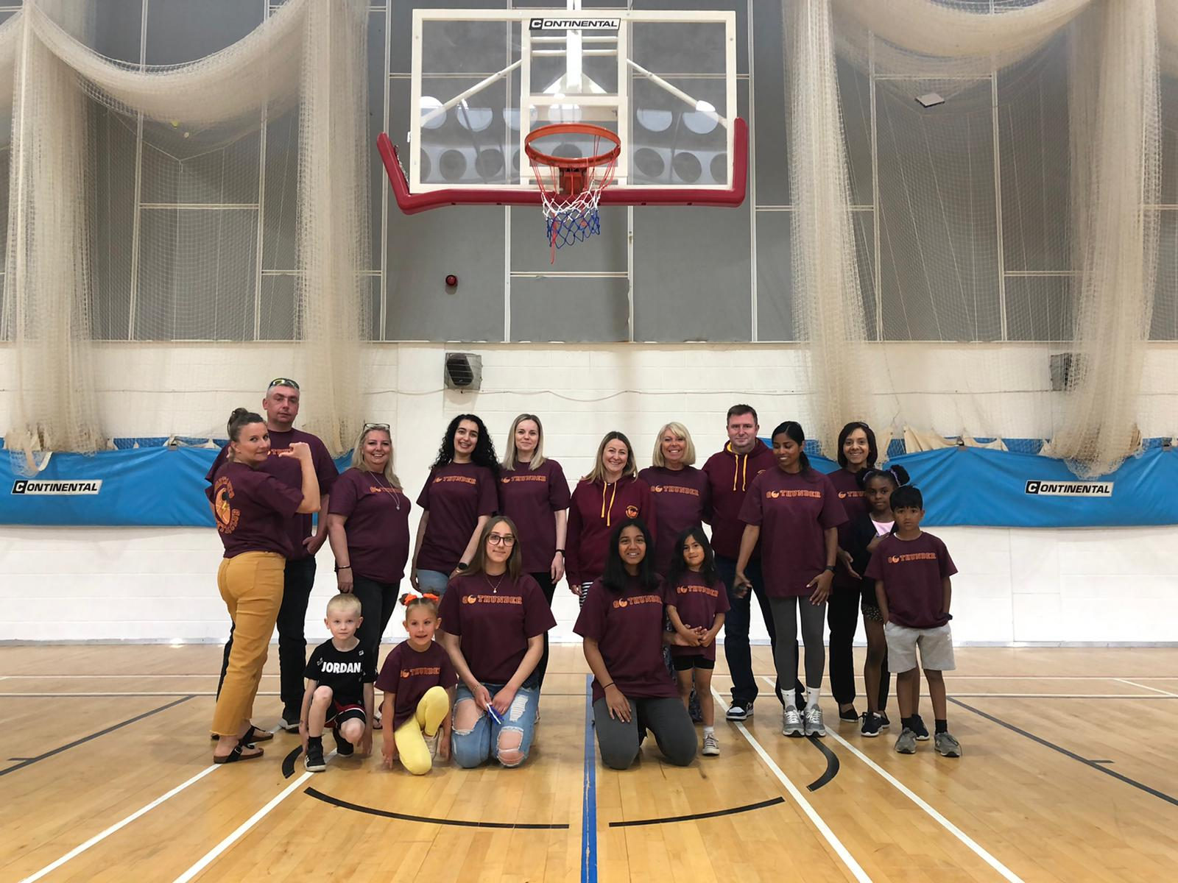

Supporters who made the long trip to Hereford for the YBL Under 13 Boys Play Offs

YBL Under 15 Boys Primis Play Off Sem-Final

Leicester “Riders” 56 -49 Northants “Thunder”

During the regular season these teams had shared games so a close game was anticipated and so it proved with physicality and street cred once again being the decisive factor.

“Thunder” made a poor start to the game and found scoring extremely difficult against the robust “Riders” whose players were quite happy to foul to prevent scores and at the end of the first quarter “Riders” had established a16-10 advantage. “Thunder” edged the second quarter 14-12 to reduce the deficit to 24-28 at half time but their offensive efforts had been handicapped by a head injury to their leading scorer Thomas Bates.

The physical nature of the game continued in the third quarter which “Riders” took 16-13 thanks to a surge of scoring from Scott and at 39-45 going into the final quarter a massive effort was needed from the Northants boys. They gave absolutely everything in that last quarter but just couldn’t find the decisive scoring thrust as “Riders” held on for the 56 to 49 points victory.

For “Thunder”, Bates top scored with 15 points, Jude Derby-Johnson, Logan Ormshaw, and Jake Muxlow providing valuable support. Coach Brad Hughes was full of praise for his team with all 11 players getting court time and eight of them contributing to the scoring.

This is the first season the Northants club has participated in the Youth Basketball League and Club President, John Collins expressed his pleasure with the way things had gone, “We have really enjoyed our first season in the YBL and have been very impressed with the organisation of the leagues. Participation has allowed our Under 11, 13 and 15 boys to play against boys of their own age. Previously we have been forced to play a year young in Basketball England competitions and often this hasn’t been very satisfactory.

We will be back next season with the same age group teams and hopefully we will be able to work with the YBL Management Committee in establishing an Under 13 Girls competition.”

With defeat in the YBL Play Offs the 2021 / ’22 competitive season ends for the Northants Basketball Club but the Club’s Summer Programme and Casual Sessions will continue.

Any boy or girl interested in playing competitive or casual basketball should contact Karen Goodrich by email

Northantsbasketballclub@hotmail.co.uk

THIS WEEKEND’S ACTION

Saturday 18th June

9-30am Budding “Ballers”

10-30am Junior “Ballers”

11-30am “Lightning” Girls Development Group

Sunday 19th June

9-30am “Storm” Boys Under 13 Development Group

For further information about this Press Release contact John Collins on +44 7801 533151

